Hunslet Carr Primary School

Nursery Home Learning Pack

Please upload any work the children complete to Tapestry. We can comment on your pictures, helping you with tips and ideas!

Below are a number of every day challenges you can ask your children to complete at home:
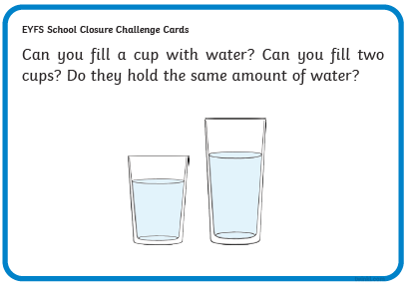
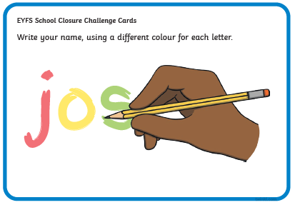
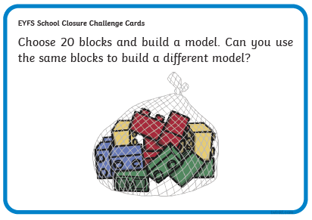
Carefully follow the lines and remember to hold your pen correctly.
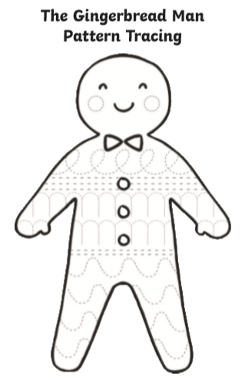
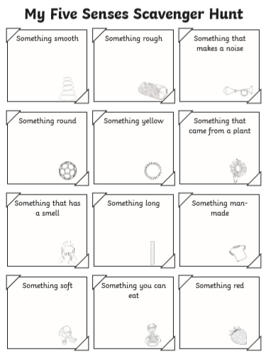
Use your senses and enjoy completing the Scavenger Hunt. You might add other things that you find.

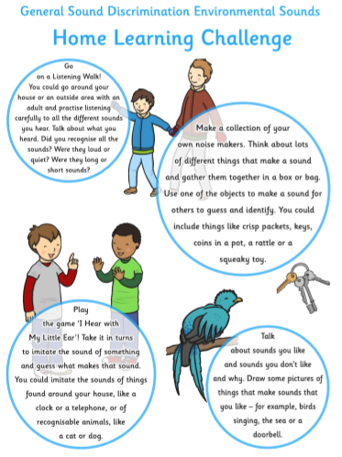
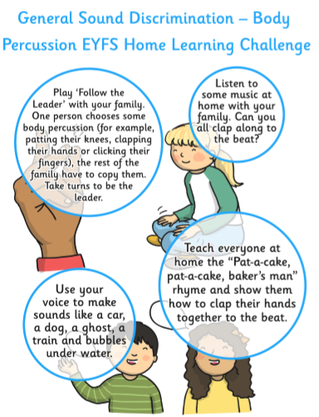
In Maths we are working with numbers to 10. Cut out the numbers and place them in order - identify your chosen number.
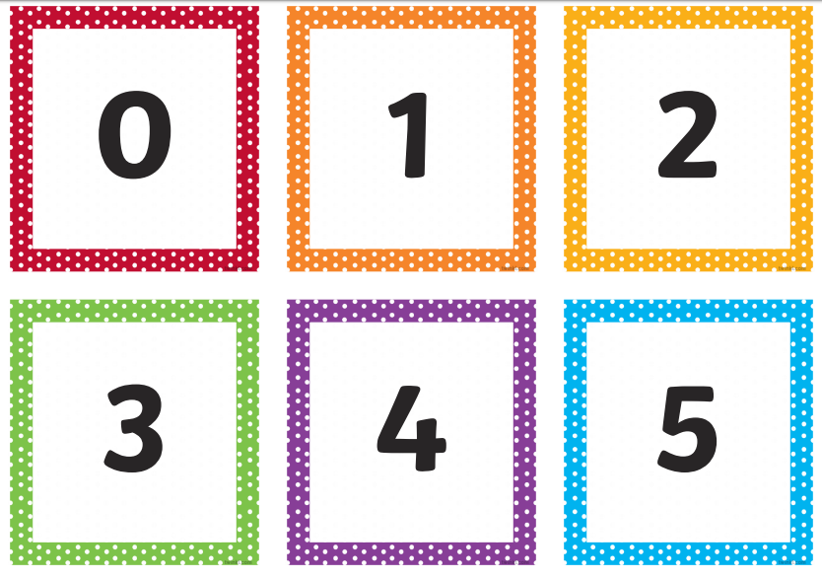

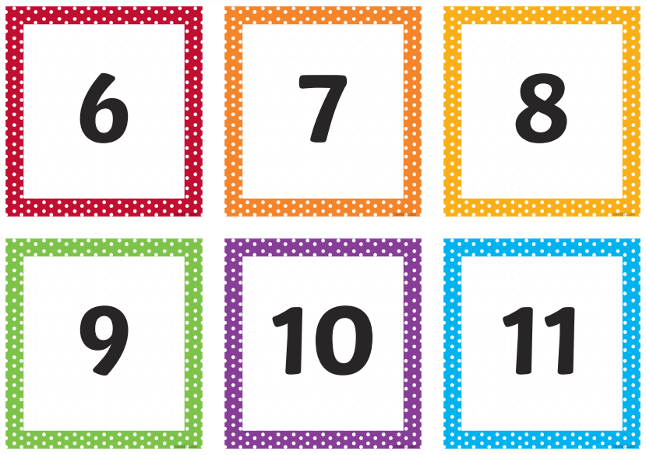

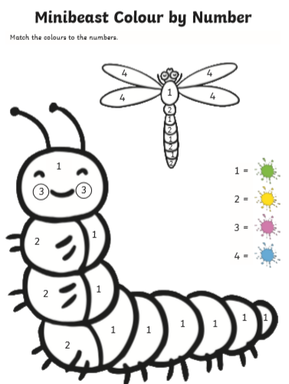
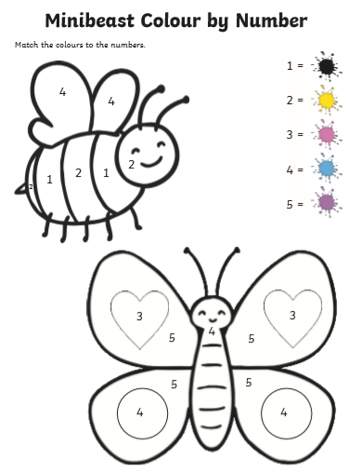
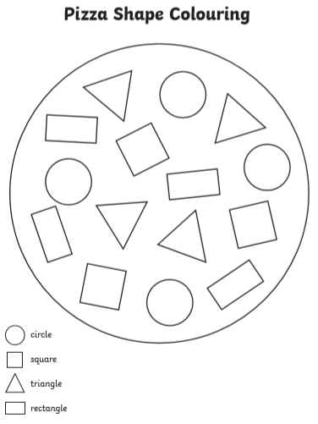
We have been looking at 2D shapes. Can you go on a shape hunt around your house and take pictures of what you find.

Please upload any home learning challenges to Tapestry including any baking or creative activities you find yourself doing.
Please ensure you stay familiar with, and follow, the current advice provided by Public Health England.
Remember to continue to wash your hands.
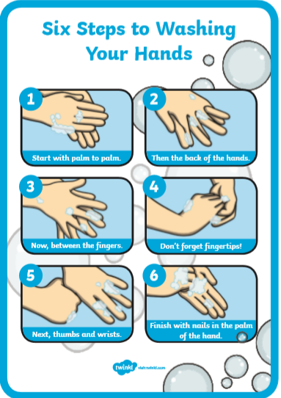

We hope to have you back at school soon!
Best Wishes – The Nursery Team

