Hunslet Carr Primary School

Reception Home Learning Pack

Please upload any work the children complete to Tapestry. We can comment on your pictures, helping you with tips and ideas!

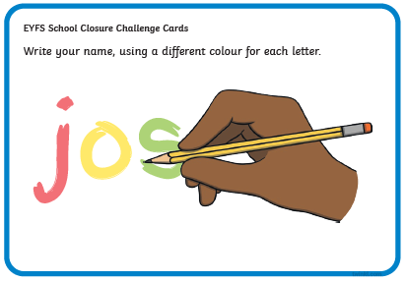
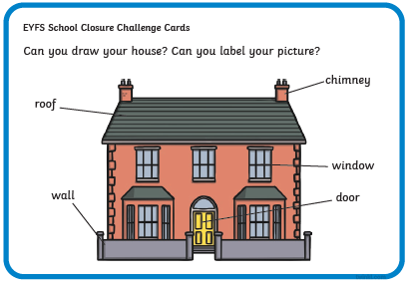
Below are a number of every day challenges you can ask your children to complete at home:

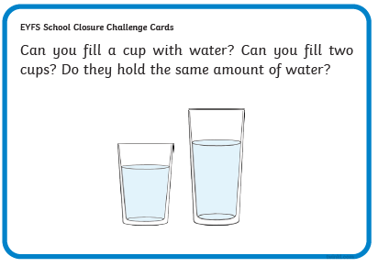
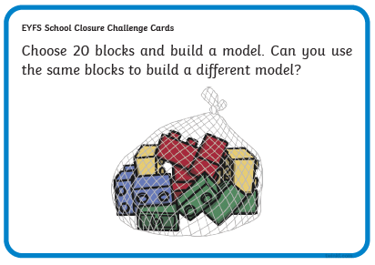

In Maths we are working with numbers to 20. Placing them in order and saying which number is one more and one less. You can also have a go at choosing a number and counting on or back.
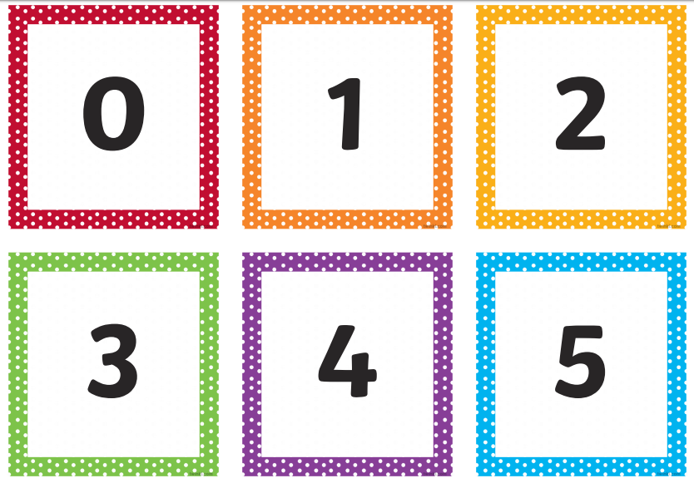
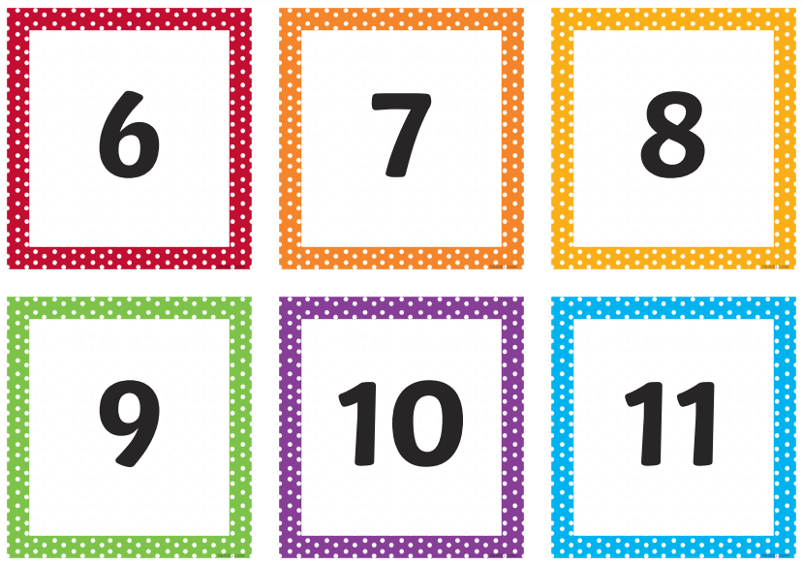

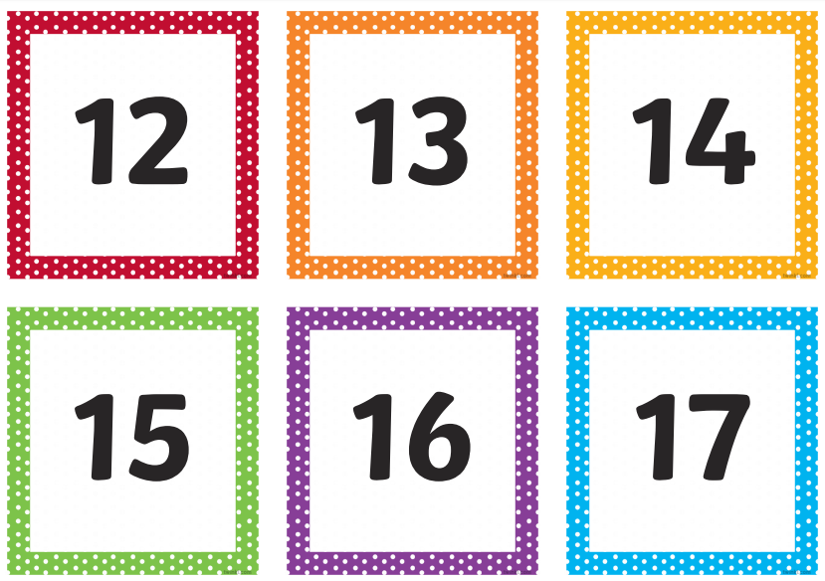

We have also been looking at 2D and 3D shapes. Can you go on a shape hunt around your house and take pictures of the 3D and 2D shapes you can spot!

To help your children write please find attached a sound mat and the tricky words they should know. Please note we have covered all the tricky words and sounds. These are to be recognised not only by themselves, but also in stories they are reading themselves. Please continue to read daily with the children as well as share stories together.
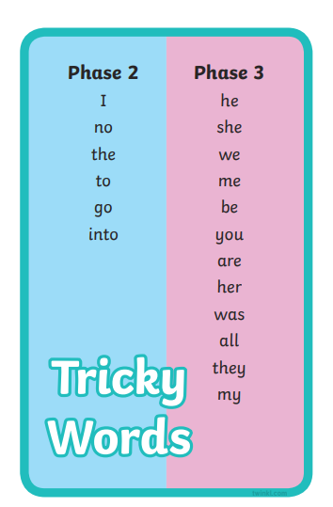

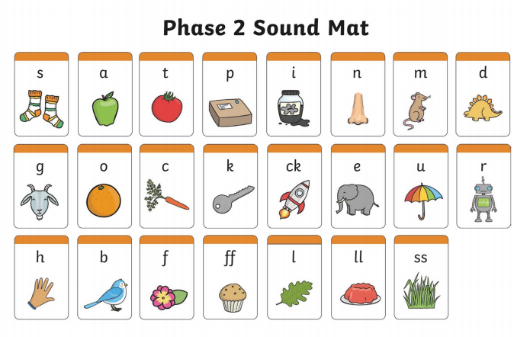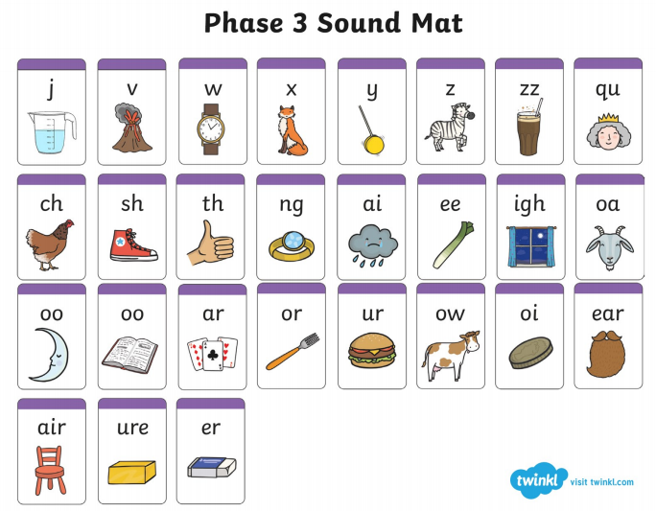
The Early Learning Goals (ELGs) are the goals or targets children are expected to achieve at the end of their Reception year. They will be working towards these goals throughout the Early Years Foundation Stage. There are 17 ELGs across all the areas of learning as shown below:
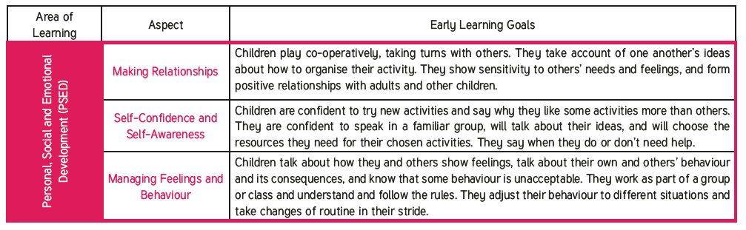
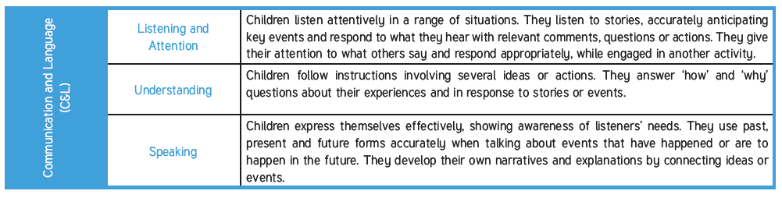
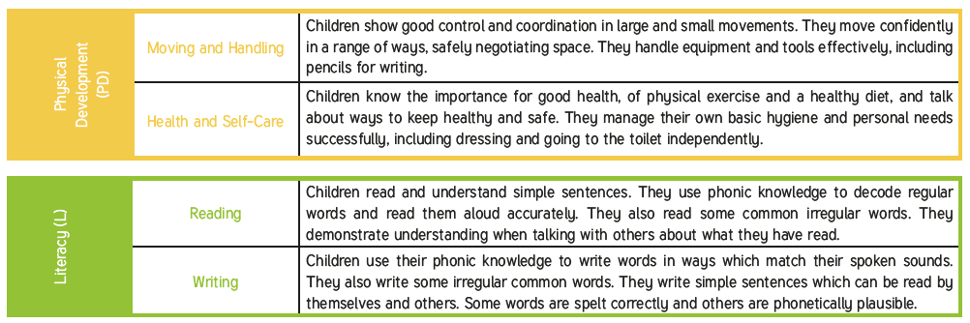

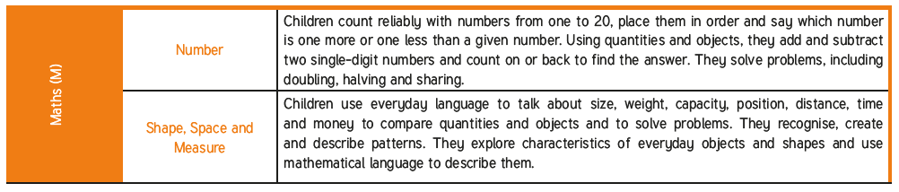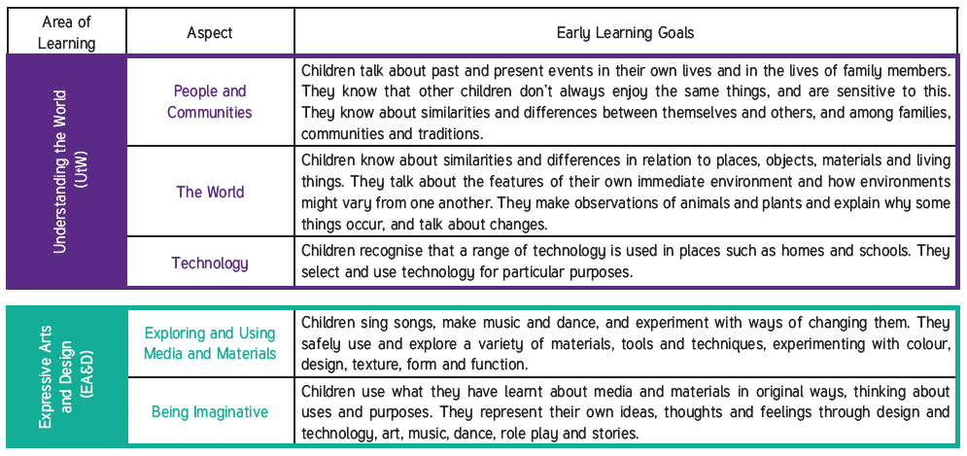

Activities to Try at Home
Here are a selection of ideas and activities split into the different Areas of Learning that you can do to help your child work towards achieving their early learning goals.
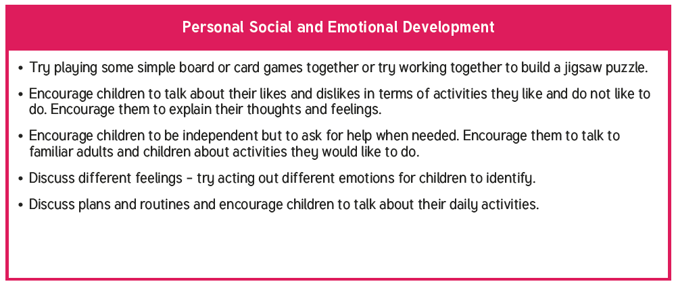

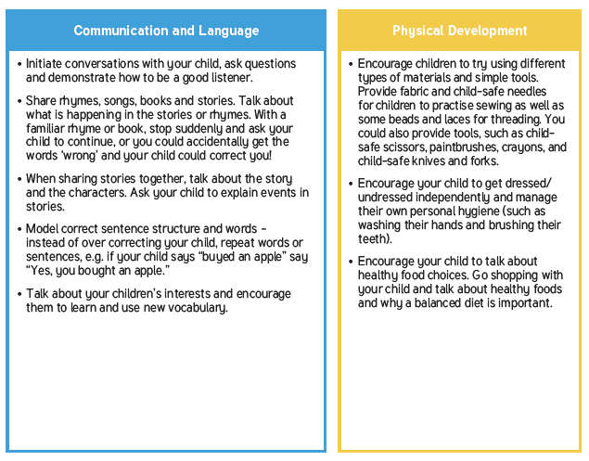

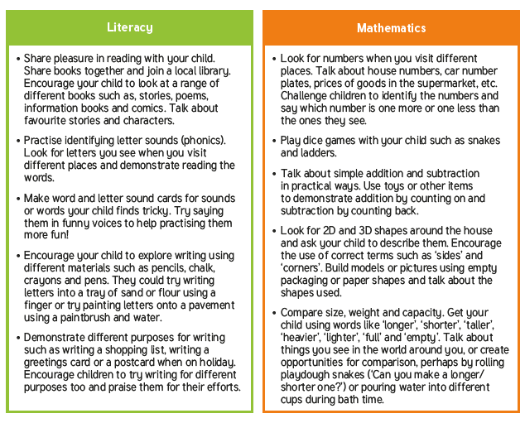

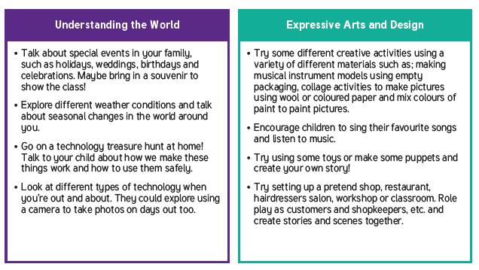

Please upload any home learning challenges to Tapestry.

Please ensure you stay familiar with, and follow, the current advice provided by Public Health England. We hope to have you back at school soon!
Best Wishes,
Reception Team

