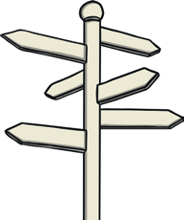

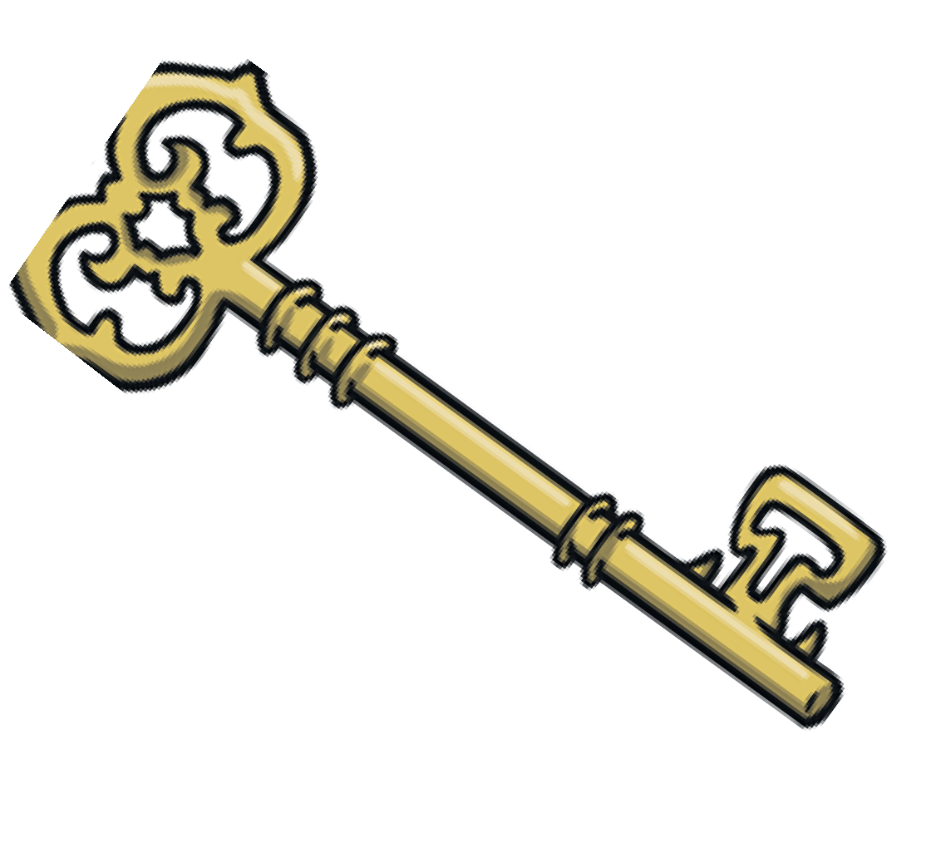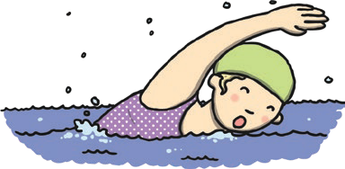

to go to your swimming lesson?

you don’t want

Are you

Preeya checked the key to make

the door was unlocked.

Add the word **sure** to these sentences.

Trace the word **sure.**

**sure**

**sure**

**sure**

Finish off the word **sure**.

Now write the full word.

Write the letters from the word **sure** inside the boxes.

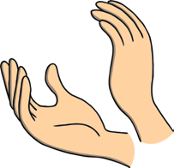

Clap the word **sure.**

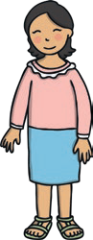

Highlight the word **sure** in these sentences.

"I am sure," said Mum.

Are you sure?

We are not sure if she will come.

Are they sure it is that way?

Find and circle the word **sure**.

|  |  |
| --- | --- |
| su_ _ | _ _re |
| s_ _ _ | _ _ _e |

|  |  |  |  |
| --- | --- | --- | --- |
|  |  |  |  |

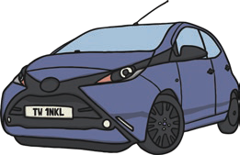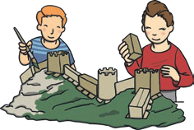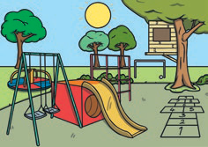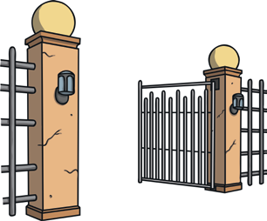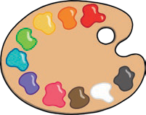

Finish off the word **who**.



Clap the word **who**.

Highlight the word **who** in these sentences.

Who is in the car?

Who are you?

Who built the model?

Who is that man?

Find and circle the word **who.**

when whole

|  |  |
| --- | --- |
| wh_ | _ho |
| _ _o | w_ _ |

Now write the full word.

Trace the word **who**.

**who**

**who**

**who**

Add the word **who** to these sentences.

did you meet at the park?

left the gate open?

painted this picture?

Write the letters from the word **who** inside the boxes.

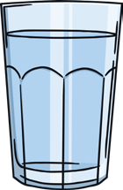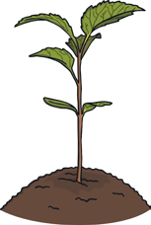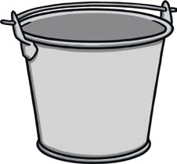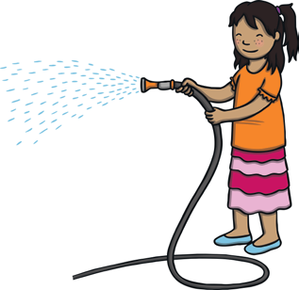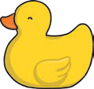

?

Do you think it will float in the

into the bucket.

I poured

Please the garden.

Clap the word **water**.

Finish off the word **water**.

Highlight the word **water** in these sentences.

I drink water every day. The water is very cold.

Plants need water to grow. Would you like some water?

Find and circle the word **water**.

who

who

|  |  |
| --- | --- |
| wa_ _ _ | _ _ter |
| _ _ _ _r | w_ _ _ _ |

Now write the full word.

Trace the word **water**.

**water**

**water**

**water**

Add the word **water** to these sentences.

Write the letters from the word **water** inside the boxes.

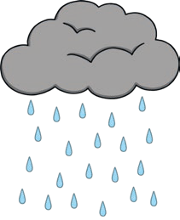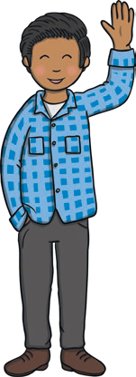

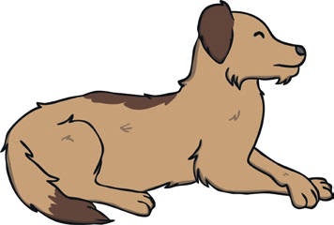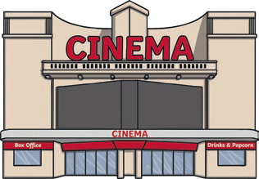

Add the word **again** to these sentences.

I saw the nice dog at the park .

We will never do it .

I want to see that film .

Trace the word **again**.

**again**

**again again**

Write the letters from the word **again** inside the boxes.

Finish off the word **again**.

Now write the full word.



Clap the word **again.**

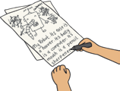

Highlight the word **again** in these sentences.

I saw him again today.

See you again soon.

Try again.

It’s raining again!

Find and circle the word **again**.

after

any

|  |  |
| --- | --- |
| ag_ _ _ | _ _ _in |
| _ _ _ _n | a_ _ _ _ |

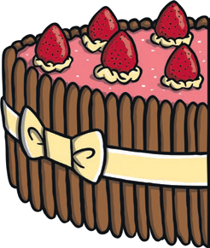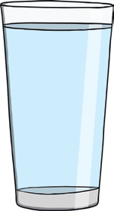

an hour late.

The train was

The glass was full.

the cake was left over after the party.

Add the word **half** to these sentences.

Trace the word **half**.

**half**

**half**

**half**

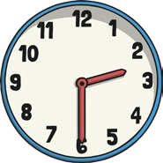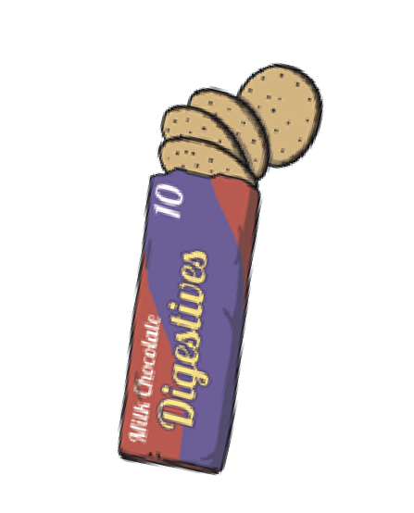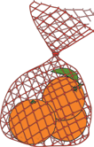

Highlight the word **half** in these sentences.

I only had half a biscuit.

It is half past two.

Half the class were away.

We had oranges at half time.

Finish off the word **half**.

Now write the full word.



Clap the word **half**.

Write the letters from the word **half** inside the boxes.

Find and circle the word **half**.

half

half

|  |  |
| --- | --- |
| ha_ _ | _ _lf |
| h_ _ _ | _ _ _f |