The Farmer and his Sons
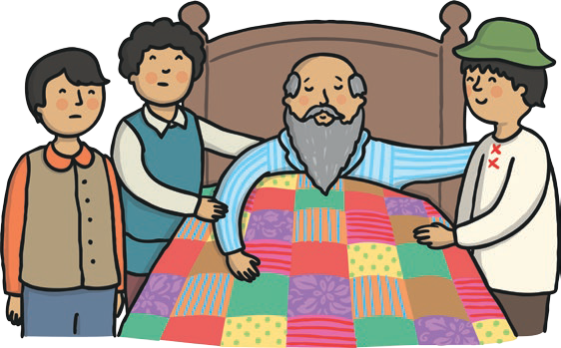
One day, there was an old farmer who had worked hard all his life. He was very ill. He had three sons. He wanted them to be good farmers. He said to them, “There is a treasure in my land. Promise me that you will look for it.” Sadly, the father died. The sons looked for the treasure. They dug and dug the soil. “What will we find?” they said to each other. Soon, they had dug up all of the land. They had not found
any treasure. They were upset. “All that hard work for nothing!” they said.

- Find and copy the word that the author used to describe how the sons were feeling when they did not find the treasure.

- How many sons did the farmer have?
Tick one answer.
two three four

- Why do you think the sons ‘dug and dug’ in the soil?

- Number the steps below from 1 to 4 to show the order
they happen in the explanation.

The sons dug and dug.

The sons couldn’t find the treasure.
The farmer sadly died.

The farmer told his sons to look for some treasure.

The Farmer and his Sons - Answers
- Find and copy the word that the author used to describe how the sons were feeling when they did not find the treasure.

upset
- How many sons did the farmer have?

Tick one answer.
two three
four

- Why do you think the sons ‘dug and dug’ in the soil?

Any explanation that refers to their extra effort to find the treasure, and, because they didn’t want to give up searching.

- Number the steps below from 1 to 4 to show the order they happen in
the explanation.
3 | The sons dug and dug.

2 | The farmer sadly died.

4 | The sons couldn’t find the treasure.

1 | The farmer told his sons to  look for some treasure.

