Year 1 Reading Revision Mat Guidance
To complete each reading revision mat, you will need to read a short text; these will be taken from either a fictional story, a non-fiction text or a poem. Once you have read and understood the text, you will have to answer questions based on what you have read. Each question will be one of five different question types.
Each of the five different question types has its own helper to remind you of what to do:
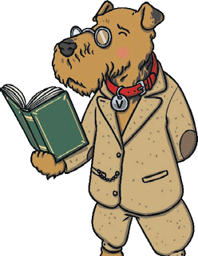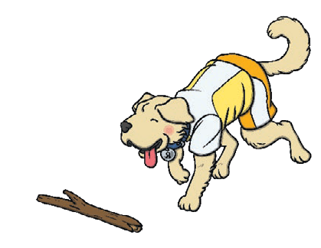
Vocabulary Questions with Vocabulary Victor
Vocabulary Victor will help you to look at how authors and poets have chosen to use certain words and phrases.
Retrieval Questions with Rex Retriever
Rex Retriever will help you to go into a text and retrieve the facts.

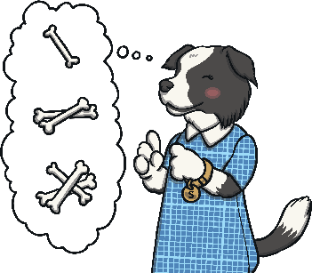
Sequence Questions with Sequencing Suki
Sequencing Suki likes everything in order! She will help you sequence the events in a text.
Inference Questions with Inference Iggy
Inference Iggy will help you hunt for clues in a text about how someone might be feeling or why something is happening.

Prediction Questions with Predicting Pip
Predicting Pip tries to see the future and she will help you work out what might happen next.

