**‘aw’ Spelling Activity**



**visit twinkl.com**

p s cr l cl s

j

dr d n l n

sh l

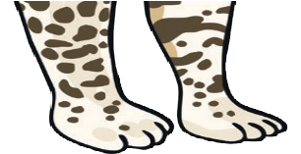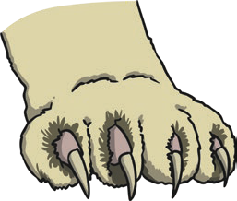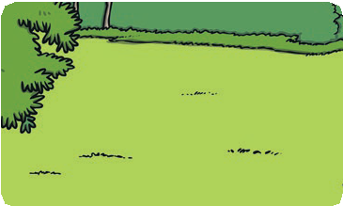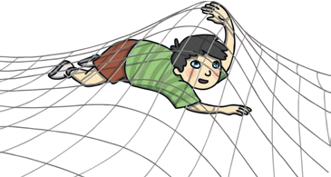

1. Trace over ‘aw’.

|  |  |  |  |  |
| --- | --- | --- | --- | --- |
| a w | a w | a w | a w | a w |
| a w | a w | a w | a w | a w |

1. Just add ‘aw’.
2. Write the correct ‘aw’ words under the pictures.