

**The Cautious Caterpillar Multiplication and Division**

**2**

The grasshopper jumps over 2 sunflowers. He

then jumps over 2 more.

How many sunflowers does the grasshopper jump over altogether?

**twinkl.com**



**The Cautious Caterpillar**

**Multiplication and Division Challenge Cards**

**twinkl.com**



**The Cautious Caterpillar Multiplication and Division**

**3** There are 10 spots on the ladybird’s back.

These are shared equally on each of her two wings.

How many spots are on each of the ladybird’s wings?

**twinkl.com**

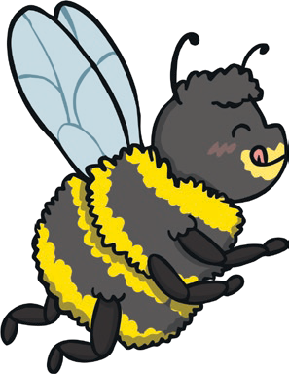

**The Cautious Caterpillar Multiplication and Division**

**1**

Cody and the bee have 5 sips of nectar each.

How many sips is that altogether?

**twinkl.com**

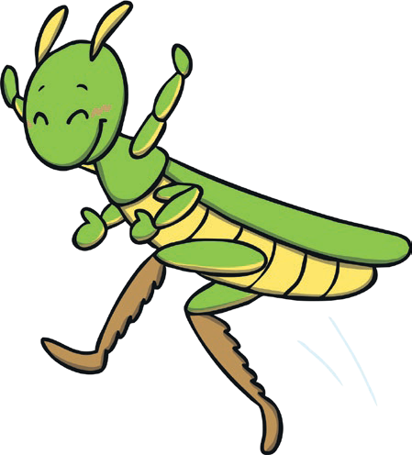

**The Cautious Caterpillar Multiplication and Division**

**6**

A grasshopper has 6 legs.

How many legs would 5 grasshoppers have in total?

**twinkl.com**



**The Cautious Caterpillar Multiplication and Division**

**4** 2 flowers lose an equal number of petals. 8 petals have fallen to the ground.

How many petals did each flower lose?

**twinkl.com**



**The Cautious Caterpillar Multiplication and Division**

**7** There are 14 stones near the stream. A frog hops on half of them.

How many stones does the frog hop on?

**twinkl.com**



**The Cautious Caterpillar Multiplication and Division**

**5** Sunflowers are planted in rows like this.

1. How many sunflowers are there altogether?
2. Can you write two multiplication calculations that show this?

**twinkl.com**

|  |  |  |  |
| --- | --- | --- | --- |
|  |  |  |  |
|  |  |  |  |



**The Cautious Caterpillar Multiplication and Division**

**10**

There are 10 sunflowers planted in each

row.

How many sunflowers will be in 5 rows in total?

**twinkl.com**



**The Cautious Caterpillar Multiplication and Division**

**8** There are some leaves on the ground. Each leaf has 2 nibbles in it.

If there are 16 nibbles, how many leaves are on the ground?

**twinkl.com**



**The Cautious Caterpillar Multiplication and Division**

**11** Cody eats 25 leaves. It takes her 5 days. She eats an equal amount of leaves each day.

How many leaves does she eat each day?

**twinkl.com**



**The Cautious Caterpillar Multiplication and Division**

**9**

The ladybird goes on holiday and flies 5

miles a day.

How many miles does she fly in a week?

**twinkl.com**



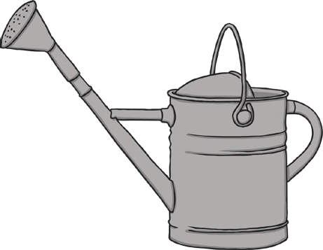

**The Cautious Caterpillar Multiplication and Division**

**12** It takes 45 litres of water to water the plants in the garden.

The watering can will hold 5 litres of water.

How many full watering cans would be needed?

**twinkl.com**



**The Cautious Caterpillar Multiplication and Division**

**1**

**2**

**3**

**4**

**9**

**10**

**11**

**12**

**5**

**6**

**7**

**8**

**twinkl.com**

|  |
| --- |
| **10 sips** |
| **4 sunflowers** |
| **5 spots** |
| **4 petals** |
| **a) 8 sunflowers**  **b) 4 x 2 = 8 2 x 4 = 8** |
| **30 legs** |
| **7 stones** |
| **8 leaves** |

|  |
| --- |
| **35 miles** |
| **50 sunflowers** |
| **5 leaves** |
| **9 watering cans** |