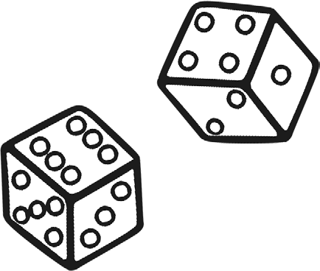
Year 2 Maths Number and Place Value Workbook

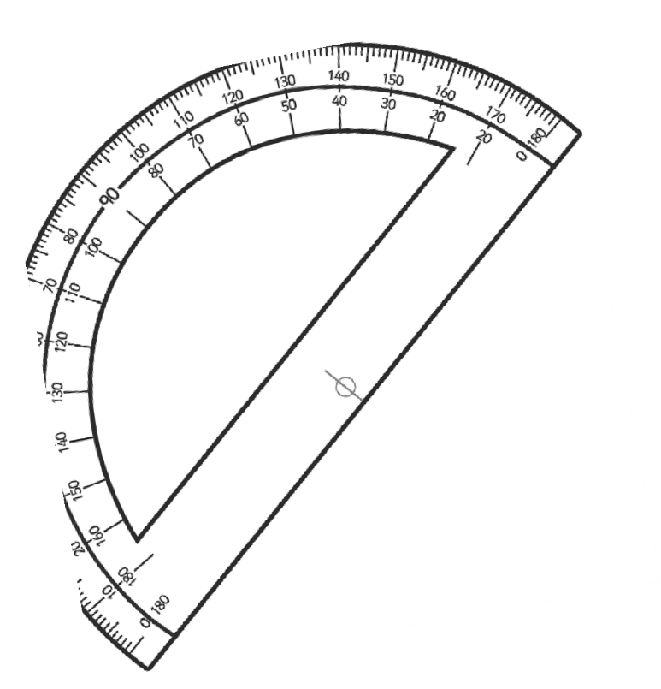
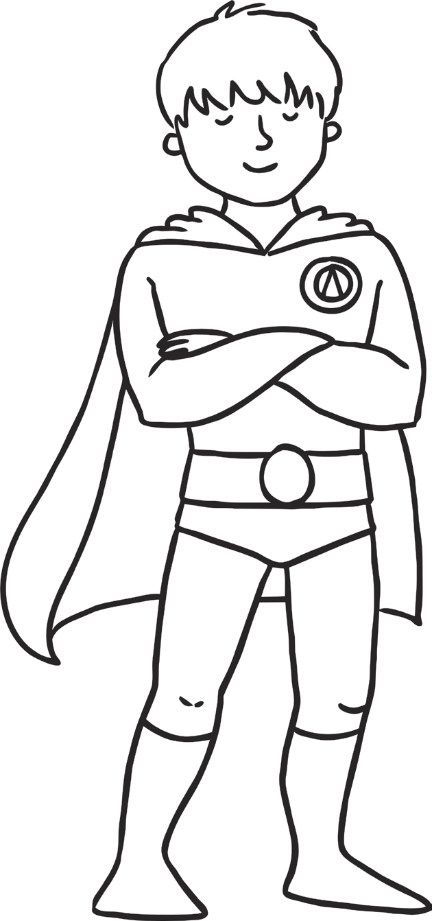

Year 2 Maths Number and Place Value Workbook
Year 2 Programme of Study – Number and Place Value

Statutory Requirements | Worksheet | Page Number | Notes
Count in steps of 2, 3, and 5 from 0, and in tens from any number, forward and backward | Counting in 2s, 3s, 5s and 10s Worksheet | 3
Recognise the place value of each digit in a two-digit number (tens, ones) | Place Value Worksheet 1, 2  and 3 | 4 - 6
Identify, represent and estimate numbers using different representations, including the number line | Representing Numbers Worksheet 1, 2, 3 and 4 | 7 - 10
Compare and order numbers from 0 up to 100; use <, > and = signs | Greater Than and Less Than Worksheets | 11
Read and write numbers to at least 100 in numerals and in words | Reading and Writing Numbers to 100 | 12
Use place value and number facts to solve problems | Place Value Challenge | 13

Counting on in 2s, 3s, 5s and 10s

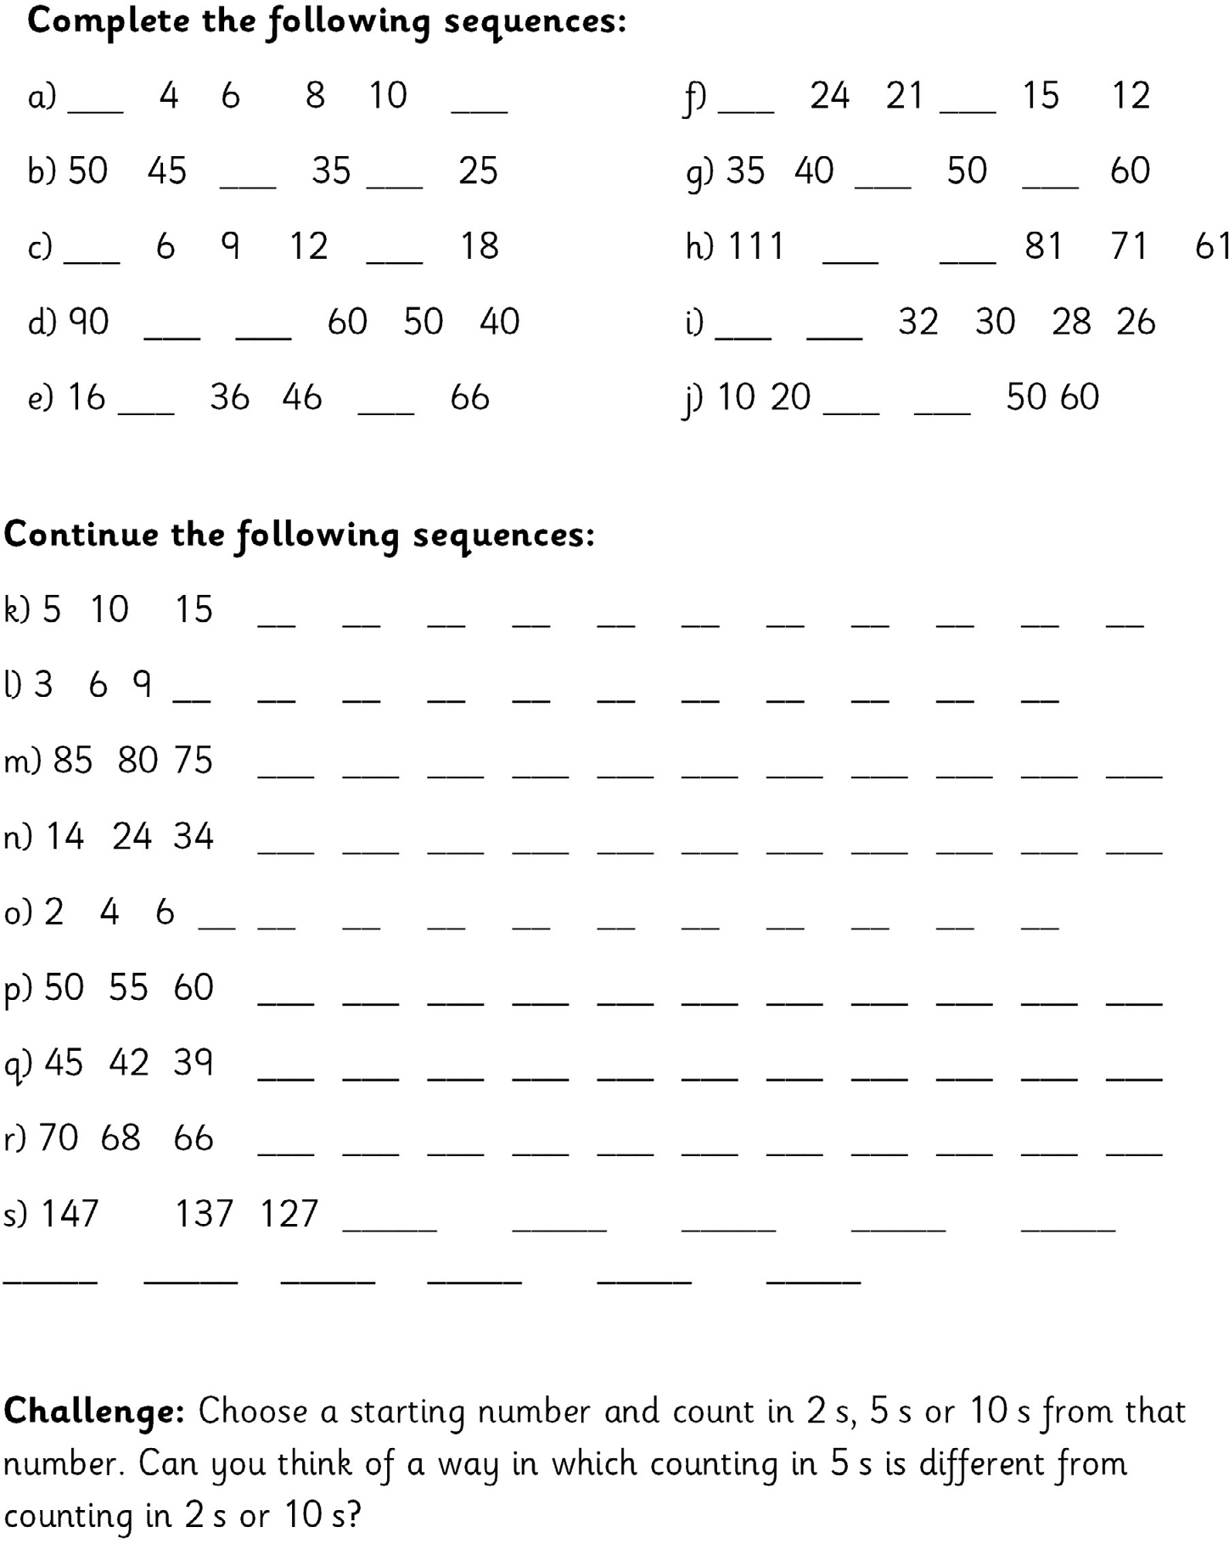

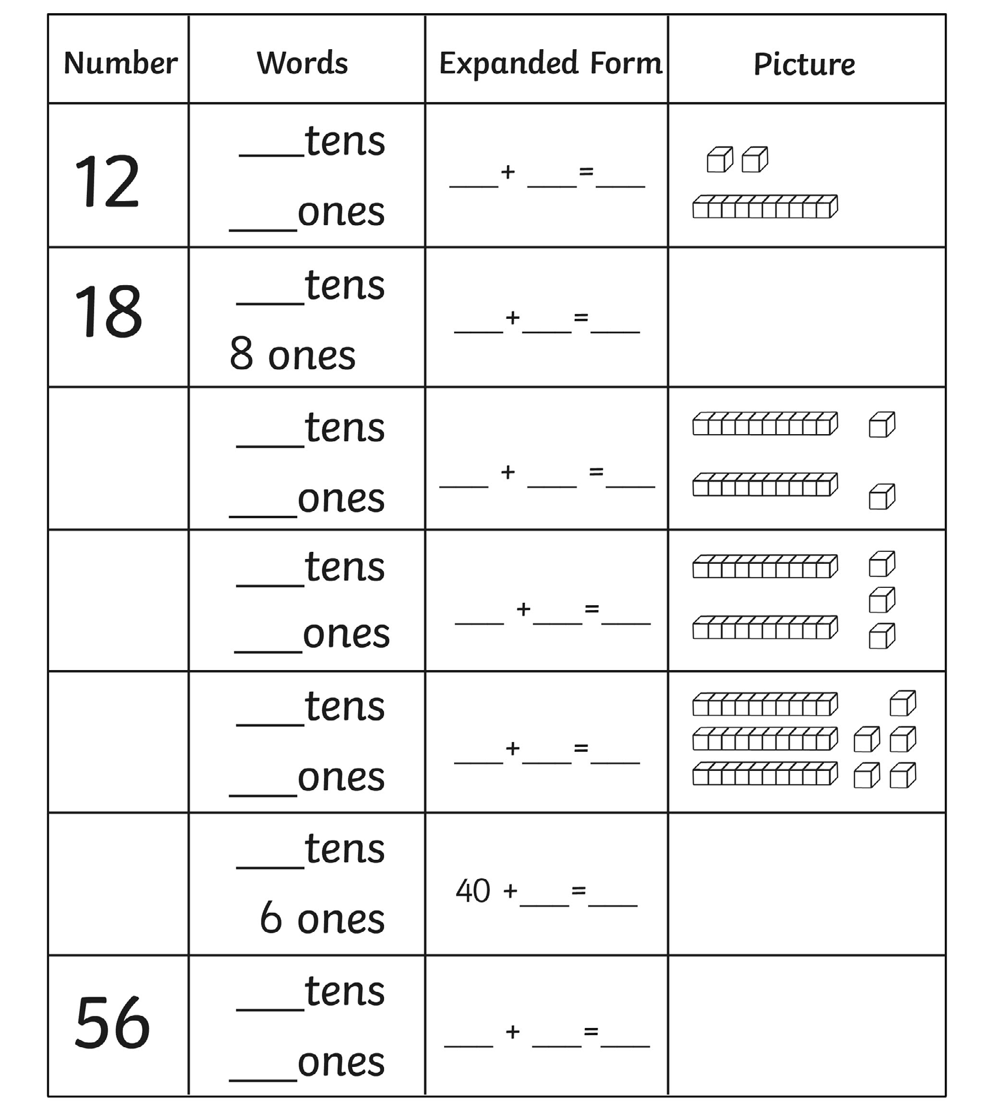

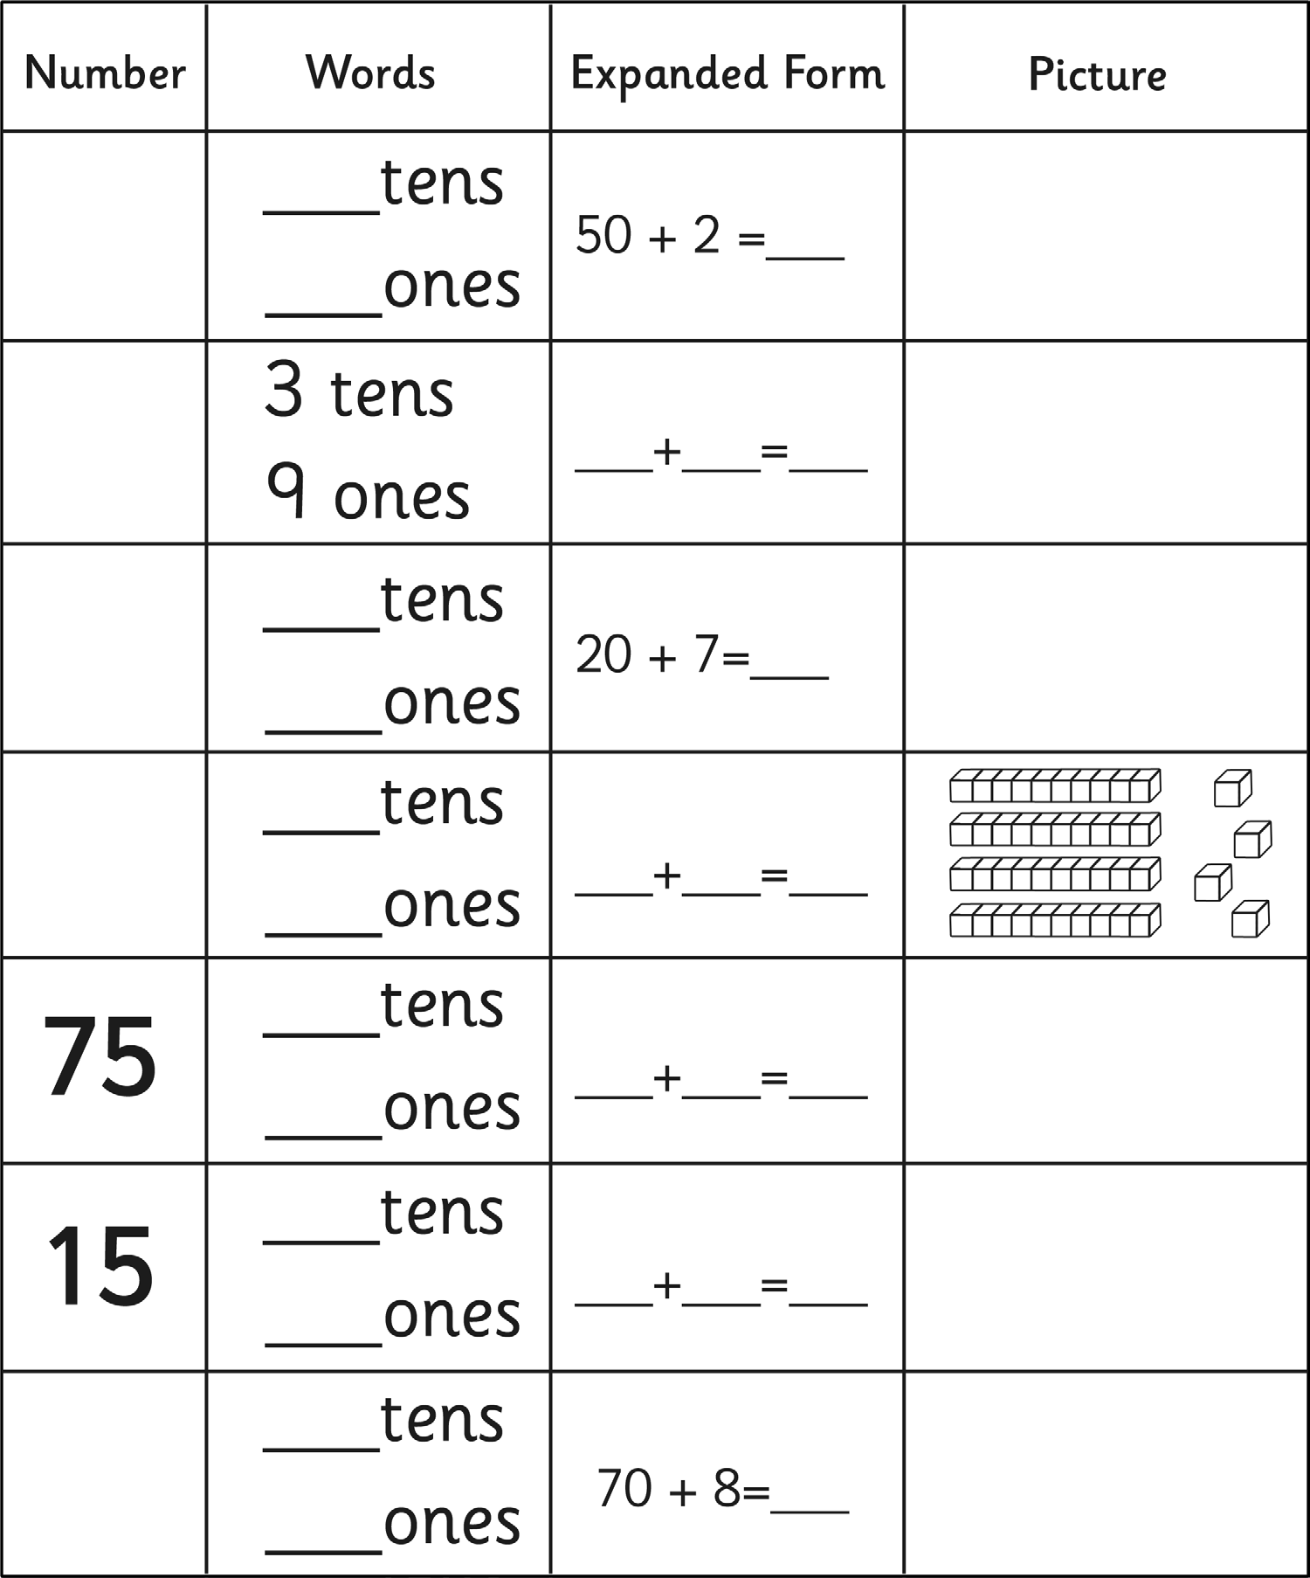

ones

ones

ones

ones

ones

ones

ones

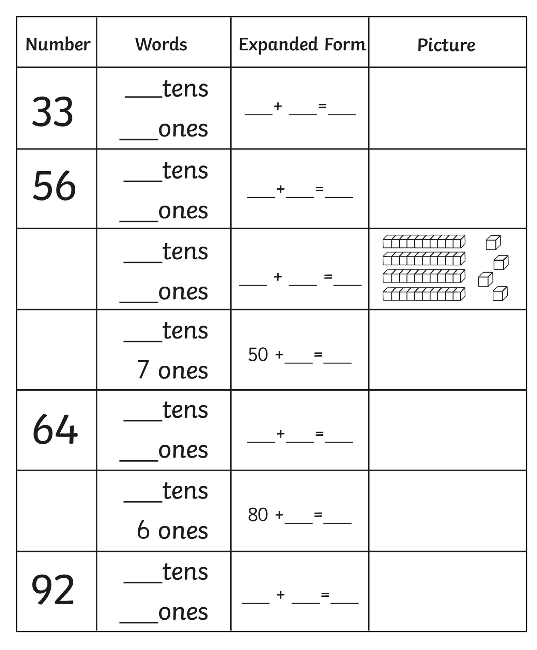

4
4

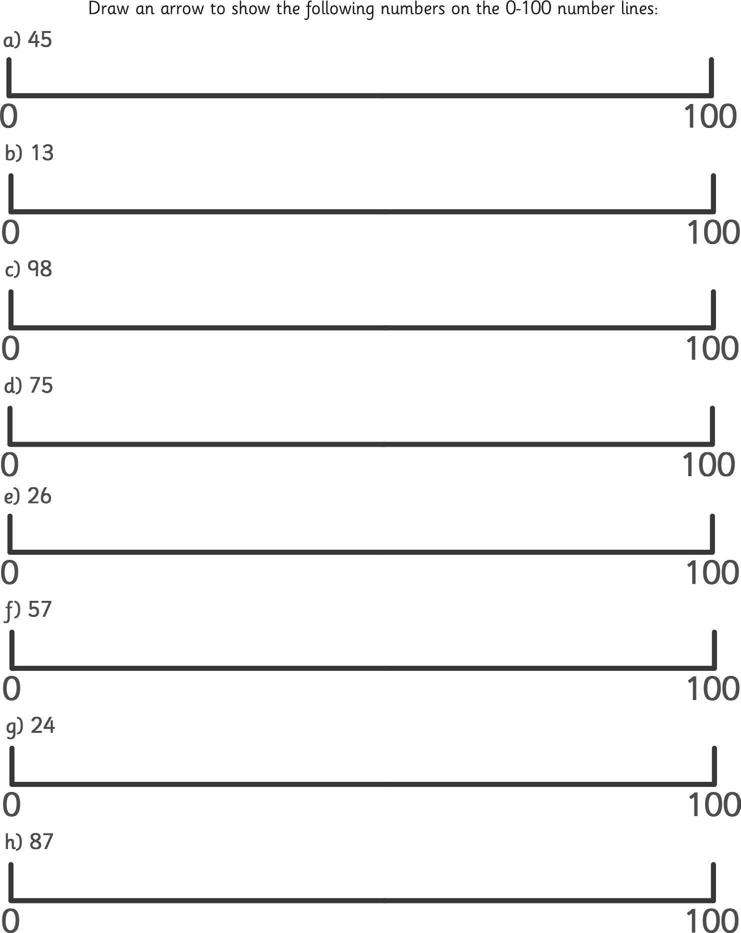

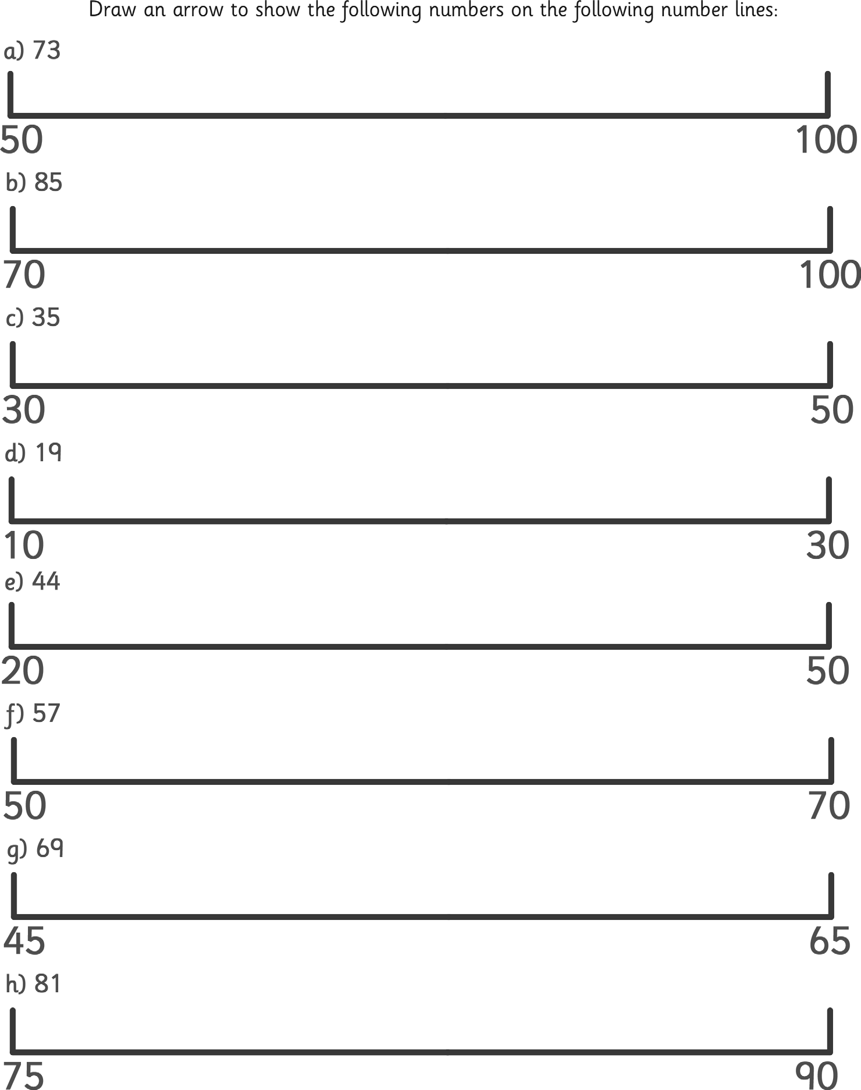

59

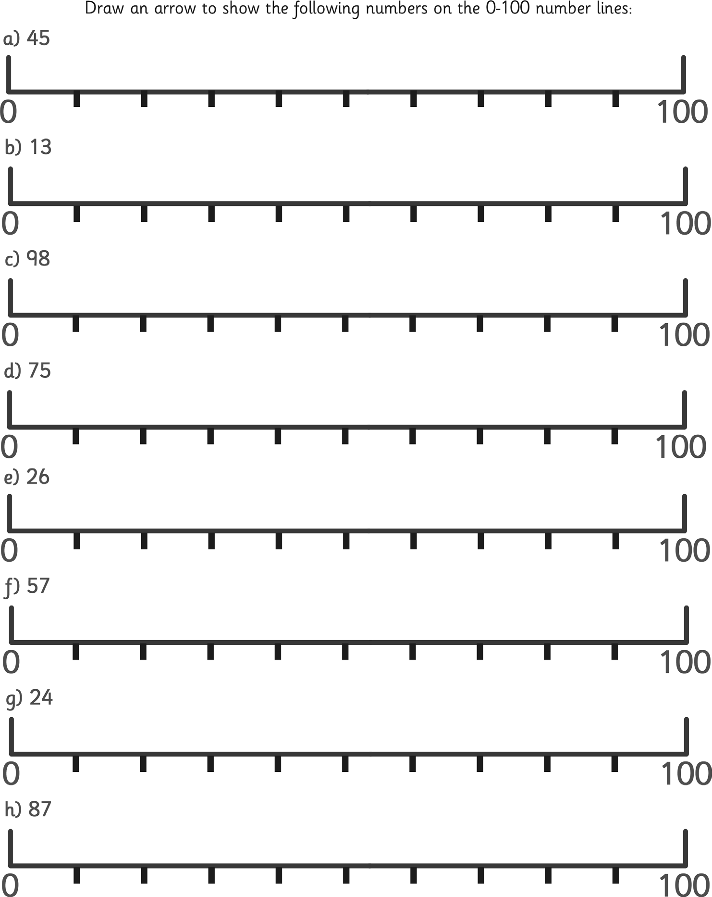

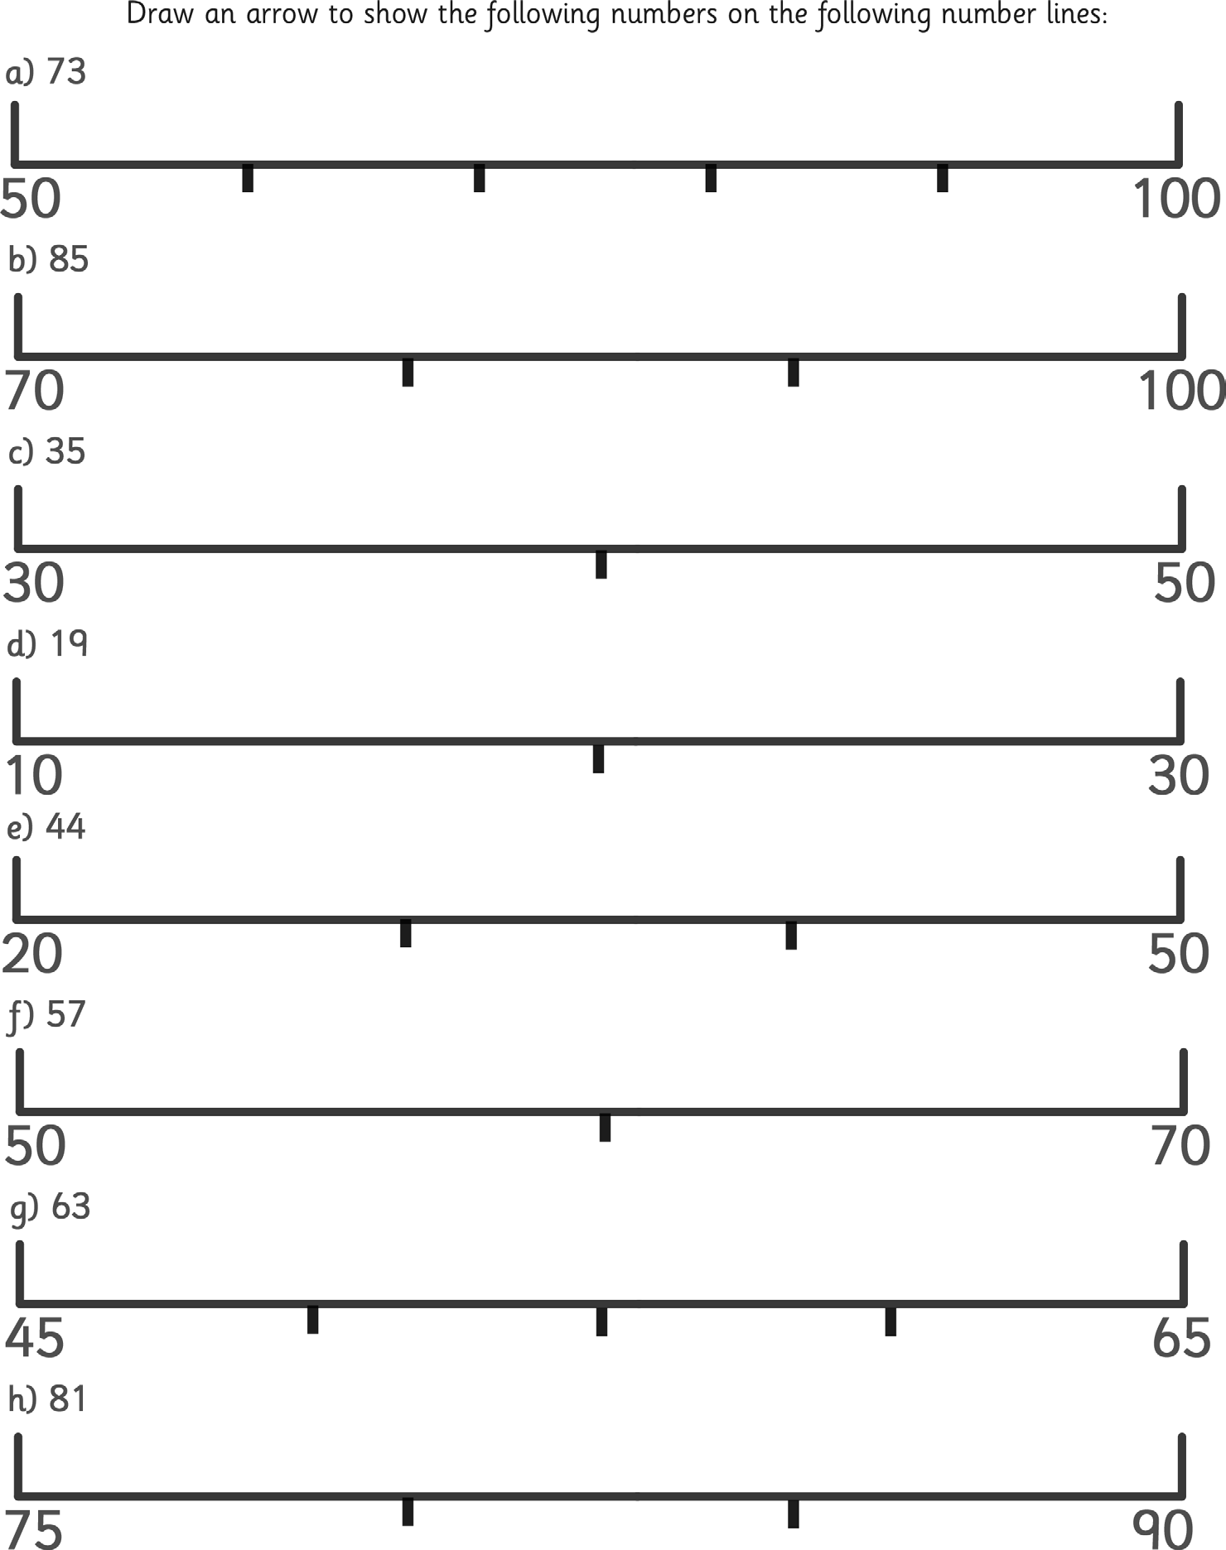

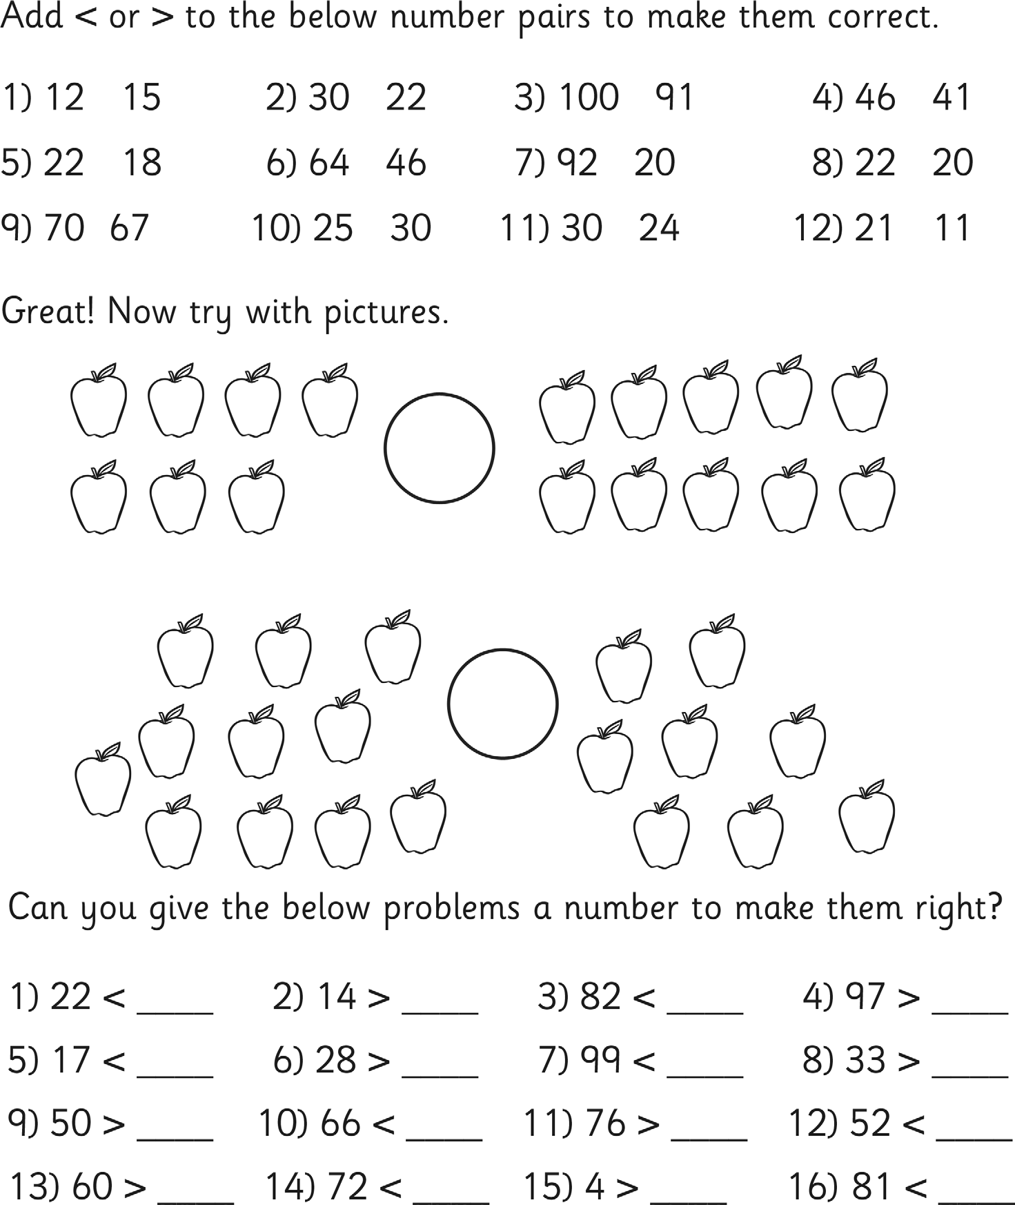

Can you fill out any missing boxes for each of the numbers below? The first one has been done for you to show you what to do.

Numerals | Number in Words | Tens | Ones | Illustration
23 | twenty three | 2 | 3
17 | seventeen
34
 | fifty six | 5 | 6
 |  | 5 | 1
49
 | eighty three
 |  | 7 | 7
Challenge

Numerals | Number in Words | Hundreds | Tens | Ones | Illustration
 |  |  |  |  | 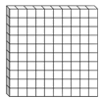

To take part in this challenge, you will need a ten sided die. If you don’t have one use a virtual dice site online.

Each time you roll a number, you must decide where to put it in the grid. The aim of the challenge is to make the value of the numbers increase each time, going on as long as you can. Follow this example through to help you think about the tactics of the game and how you can give yourself more chance to succeed.

Tens | Ones | Action
1 | 9 | First roll = 0 - Placed in ones column in row 2 Second Roll = 9 - Placed in tens column in sixth row Third Roll = 4 - Placed in tens column in third row Fourth Roll = 7 - Placed in ones column fourth row Fifth Roll = 6 - Placed in tens column fourth row Sixth Roll = 2 – Placed in tens column second row Seventh Roll = 3 – Placed in ones column sixth row Eighth Roll = 6 – Placed in ones column third row Ninth Roll = 3 – Placed in ones column fifth row Tenth Roll = 6 – Placed in ones column seventh row  Eleventh Roll = 6 FAIL – CAN’T MAKE A BIGGER NUMBER  Three bigger numbers made – points scored = 3
2 | 0
4 | 6
6 | 7
 | 3
9 | 3
 | 6
Got it? You’re ready to make a start. You could also print off another sheet to play against someone else.
Tens | Ones | Points Scored
0 | 9

Tens | Ones | Points Scored
1 | 3

Tens | Ones | Points Scored
1 | 9

