9
17
26
34
43
53
61
71
79
88
97
105
106
All about Africa
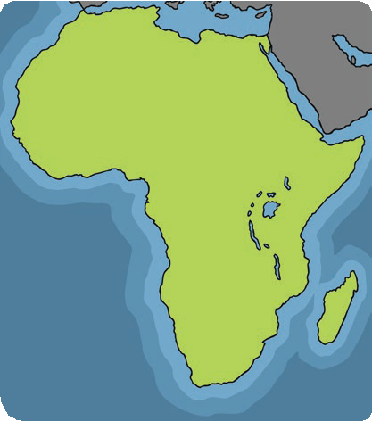
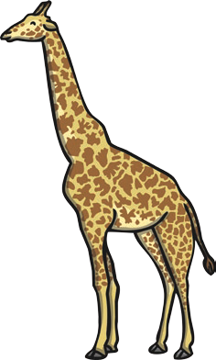
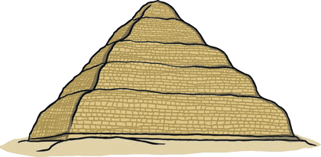
Africa is a continent which is bigger than the United States of America, Canada and India put together. Africa is home to 54 countries and more than one billion people. In Northern Africa, you can trek through the Sahara desert; it is the largest and driest hot desert in the world. You can also visit the world’s longest river, The Nile. Millions of people visit Africa on holiday to see its famous pyramids and go on animal safaris. In Africa, you will find some of the largest mammals on the planet. Among them are the elephant, the giraffe and the world’s fastest land mammal, the cheetah.

Quick Questions
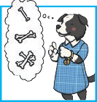
- Number these facts from 1 to 3 to show the order they appear in the text.
You can trek through the Sahara desert. Millions of people visit the famous pyramids. Africa is home to 54 countries.
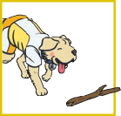
- Find and copy two mammals from the text that
you may find in Africa.

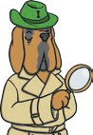
- Why might people come to Africa to look at animals on a safari?

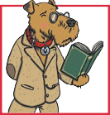
- ‘ You can trek through the Sahara desert.’
In this sentence, what does ‘trek’ mean?

9
17
26
34
43
53
61
71
79
88
97
105
106
All about Africa
Africa is a continent which is bigger than the United States of America, Canada and India put together. Africa is home to 54 countries and more than one billion people. In Northern Africa, you can trek through the Sahara desert; it is the largest and driest hot desert in the world. You can also visit the world’s longest river, The Nile. Millions of people visit Africa on holiday to see its famous pyramids and go on animal safaris. In Africa, you will find some of the largest mammals on the planet. Among them are the elephant, the giraffe and the world’s fastest land mammal, the cheetah.

Answers
- Number these facts from 1 to 3 to show the order they appear in the text.
You can trek through the Sahara desert. Millions of people visit the famous pyramids. Africa is home to 54 countries.
1
3
2
- Find and copy two mammals from the text that
you may find in Africa.
Accept any two from: elephants, giraffes and cheetahs.
- Why might people come to Africa to look at animals on a safari?
Accept any sensible justification linked to the text, e.g. They might come to Africa because they want to see new and exotic animals that they could not see in their own country in the wild.
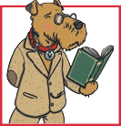
- ‘ You can trek through the Sahara desert.’
In this sentence, what does ‘trek’ mean?
Accept any reasonable definition which refers to ‘trek’ as meaning walking/hiking, etc.

