Y3 Fnu:tlo•
Challenge Cards

Y3Fluc:tlo•
Challenge Cards

Y3 Fractlo•
Challenge Cards

Y3 Fnu:tlo•
Challenge Cards

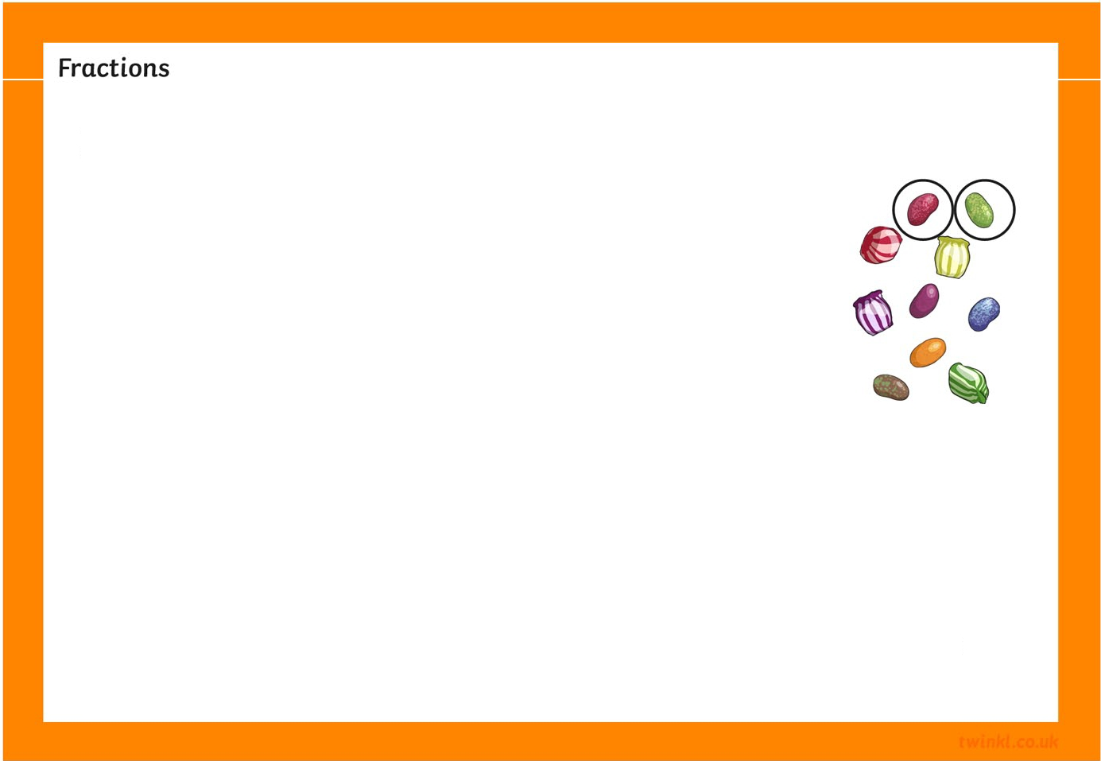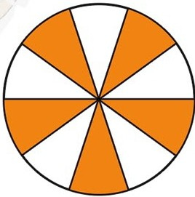
1. Complete the fractions to maRe the calculations correct. How many different ways can you find to complete them?
□8 +
□8 =
1
10+ 10= 10
How do you Rnow you have found all the possible answers?
□ □
2
2. Put the pictures in order.
-
How did you decide what order to put them in?

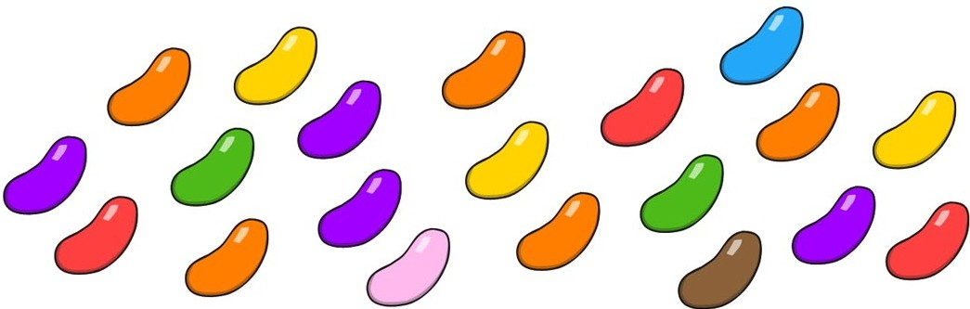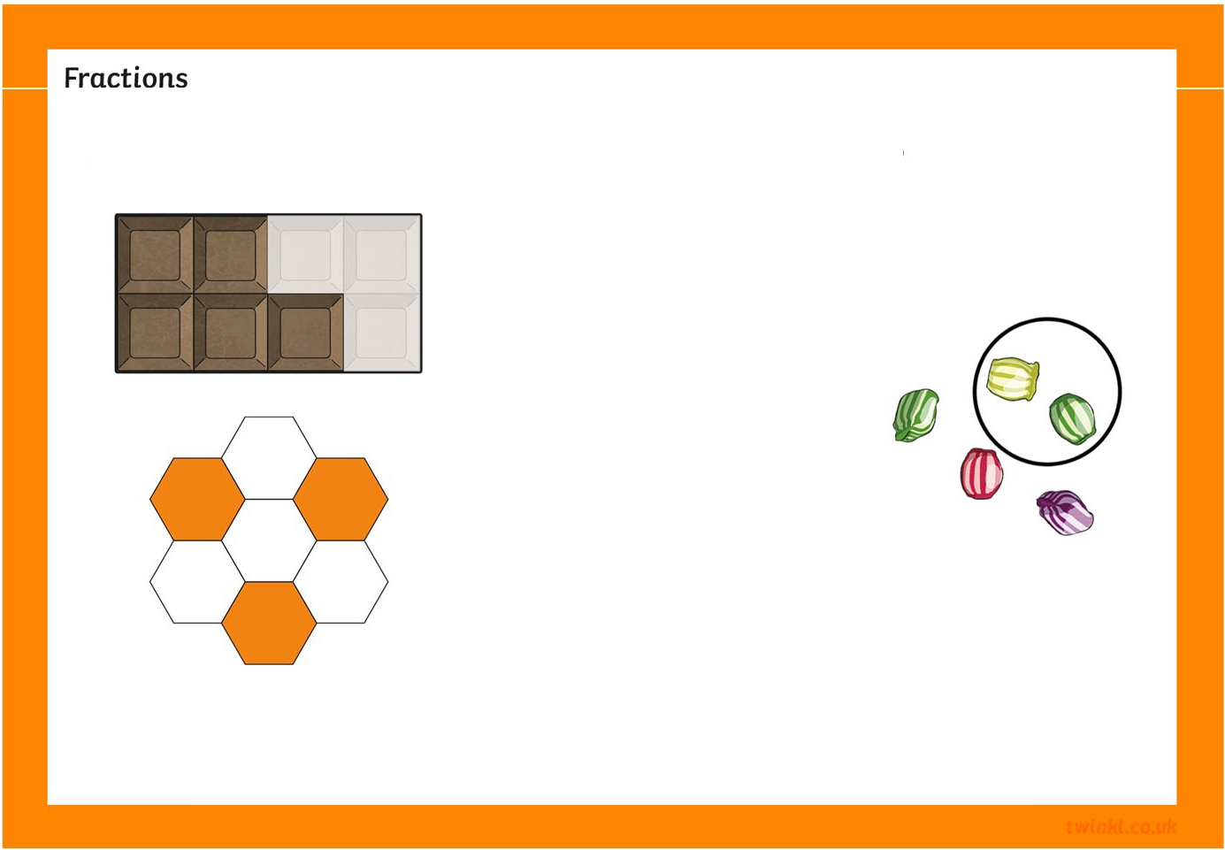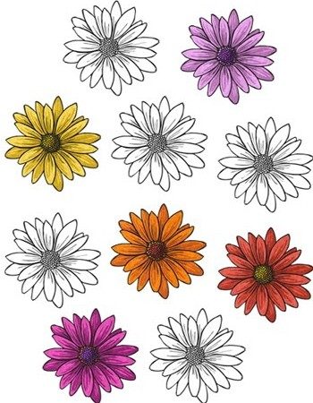
3. What fraction of the sweets are red? What fraction are green? Find the fraction of each colour.
How can you use your Rnowledge of adding fractions to checR your answer?
4. What fraction is shown by each image?
Could the images show any other fractions?

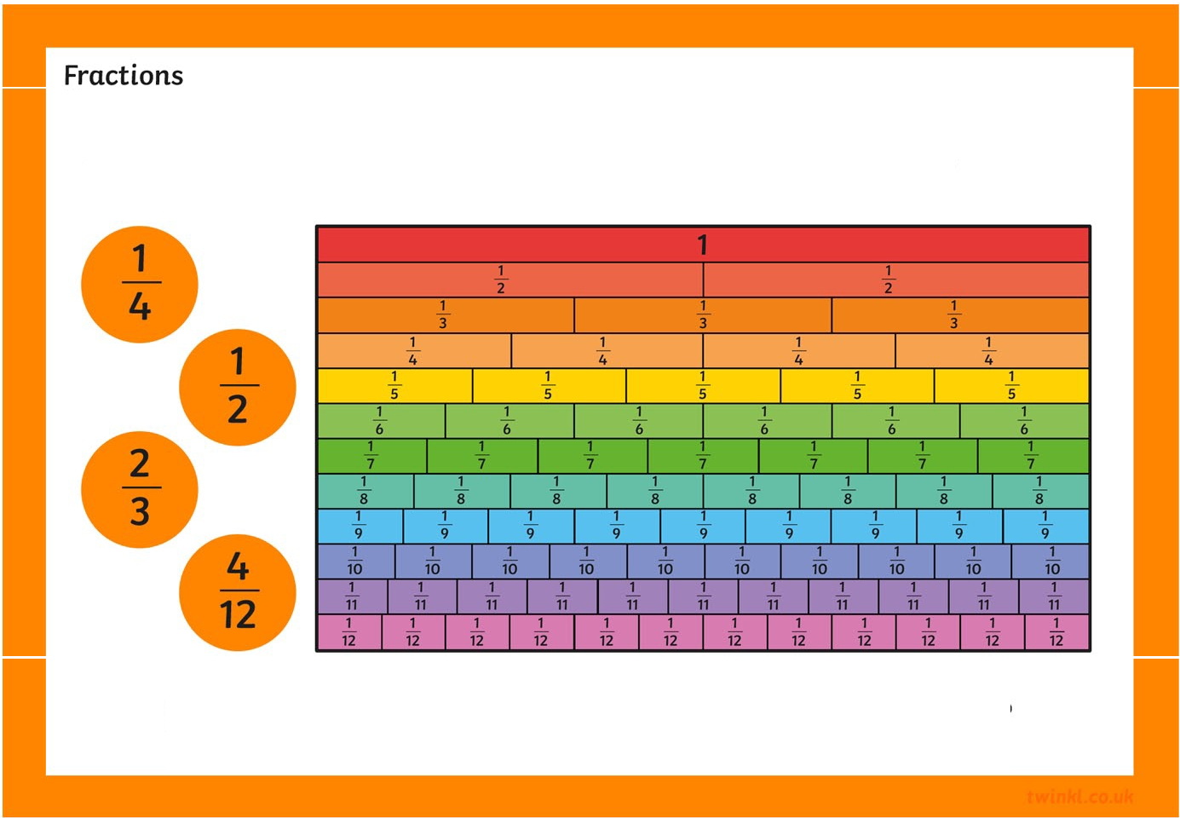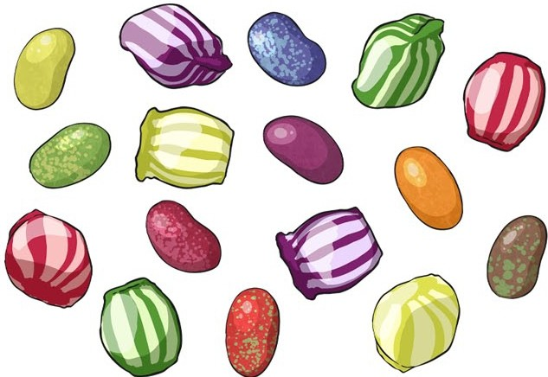
5. Find fractions which are equivalent to these.
How many equivalent fractions can you find?
6. James ate half of the sweets. Hardeep ate ! of those Left. Sam ate the rest.
How many sweets did each boy eat?

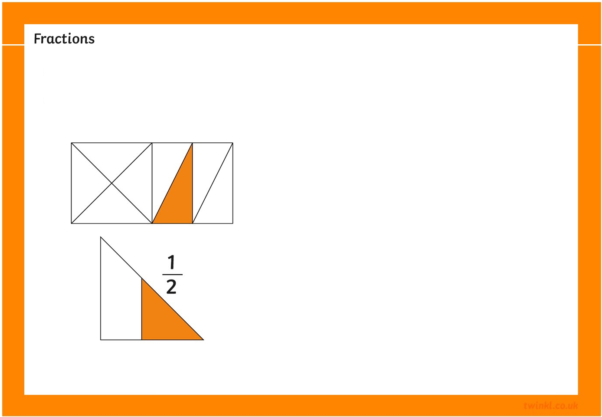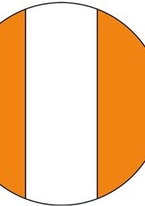
7. The images show the fractions written underneath. True or false.
2
1 3
8
I I I I I I
Can you explain you answers?
8. Draw this number Line. Show !, !
and :
.
0
Draw this number Line. Show !
1
2
and
1 .
3
0

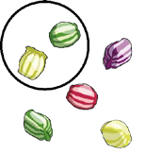
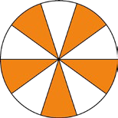
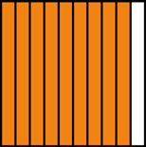
Fractions Challenge Cards

1. Complete the fractions to make the calculations |  |  |  |  |  | 2. Put the pictures in order.  a b  d e | c
correct. How many different ways can you find to
complete them?
0 | + 8 | = | 1 | 10 - 8 | = 2
8 | 8 |  |  | 10 10 | 10
1 | + 7 | = | 1 | 9 - 7 | = 2
8 | 8 |  |  | 10 10 | 10
2 | + 6 | = | 1 | 8 - 6 | = 2
8 | 8 |  |  | 10 10 | 10
3 | + 5 | = | 1 | 7 - 5 | = 2
8 | 8 |  |  | 10 10 | 10
4 | + 4 | = | 1 | 6 - 4 | = 2
8 | 8 |  |  | 10 10 | 10
 |  |  |  | 5 - 3 | = 2
 |  |  |  | 10 10 | 10
 |  |  |  | 4 - 2 | = 2
 |  |  |  | 10 10 | 10
 |  |  |  | 3 - 1 | = 2
 |  |  |  | 10 10 | 10
 |  |  |  | 2 - 0 | = 2
 |  |  |  | 10 10 | 10
3. What fraction of the sweets are red? What fraction |  |  |  |  |  | 4. What fraction is shown by each image?  2 3 5 3  or or  5 5 8 8  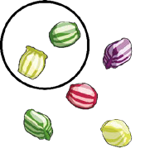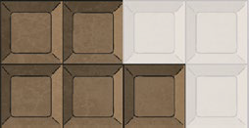  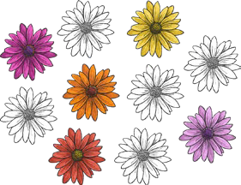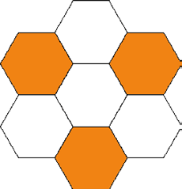  5 1 3 4  or or  10 2 7 7
are green? Find the fraction of each colour.
Red - 3/20
Orange - 5/20
Blue - 1/20
Green - 2/20
Yellow - 3/20
Pink - 1/20
Violet - 4/20
Brown - 1/20
How can you use your knowledge of adding
fractions to check your answer?
3/20 + 5/20 + 1/20 + 2/20 + 3/20 + 1/20 + 4/20 +
1/20 = 20/20 = 1

5. Find fractions which are equivalent to these.  1 = 2 3  4 8 12  1 = 2 3 4 5 6  2 4 6 8 10 12  2 = 4 6 8  3 6 9 12  4 = 3 2 1  12 9 6 3 | 6. James ate half of the sweets. Hardeep ate ¼ of those left. Sam ate the rest. How many sweets did each boy eat?  James: 8 sweets  Hardeep: 2 sweets  Sam: 6 sweets
7. The images show the fractions written underneath. True or false.  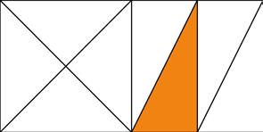  1 1  2 8  True True  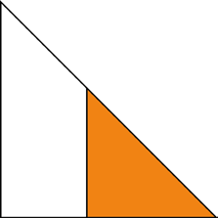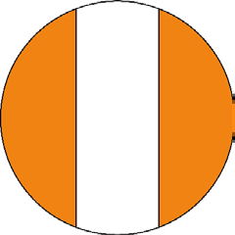  1 2  2 3  False False | 8. Draw this number line. Show 3 , 1 and 4 .  6 6 6  0 1 3 4 1  6 6 6  Draw this number line. Show 1 , 1 and 1 .  4 3 2  0 1 1 1 1  4 3 2

