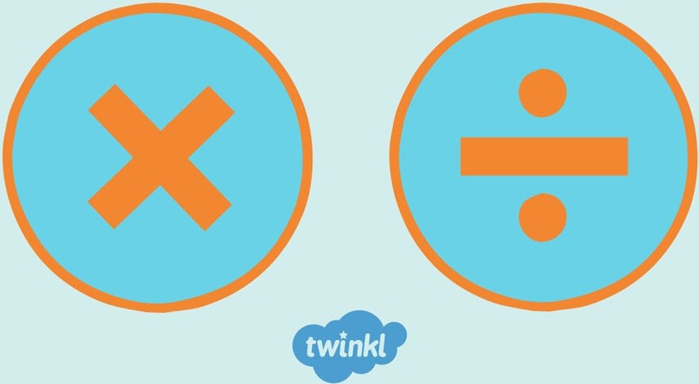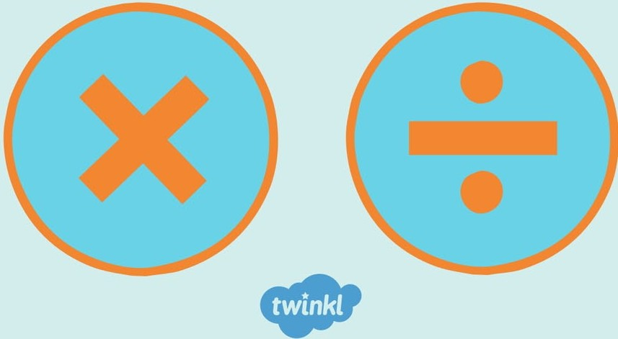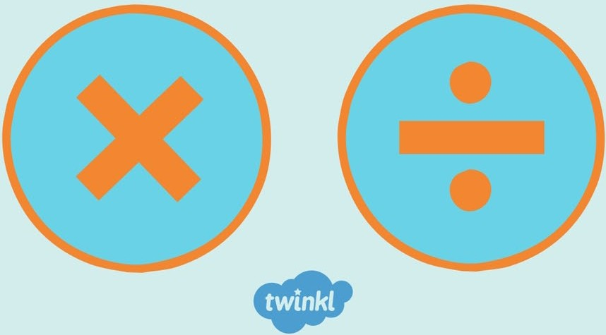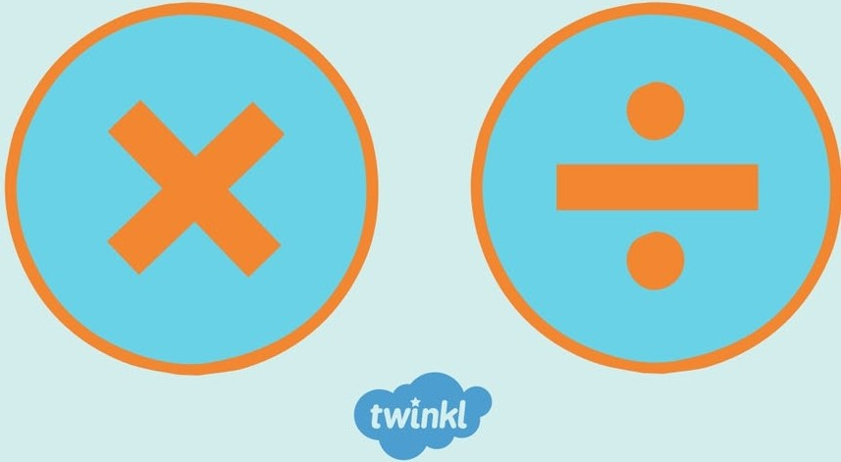
Multiplication and Division Challenge Cards
Multiplication and Division Challenge Cards
Multiplication and Division Challenge Cards
Multiplication and Division Challenge Cards

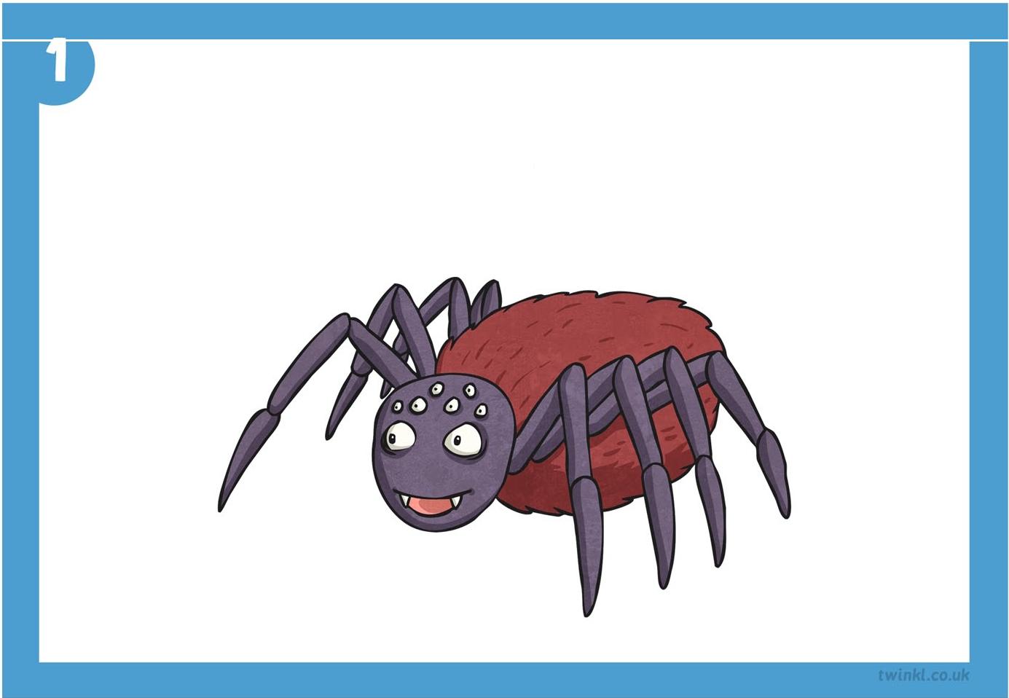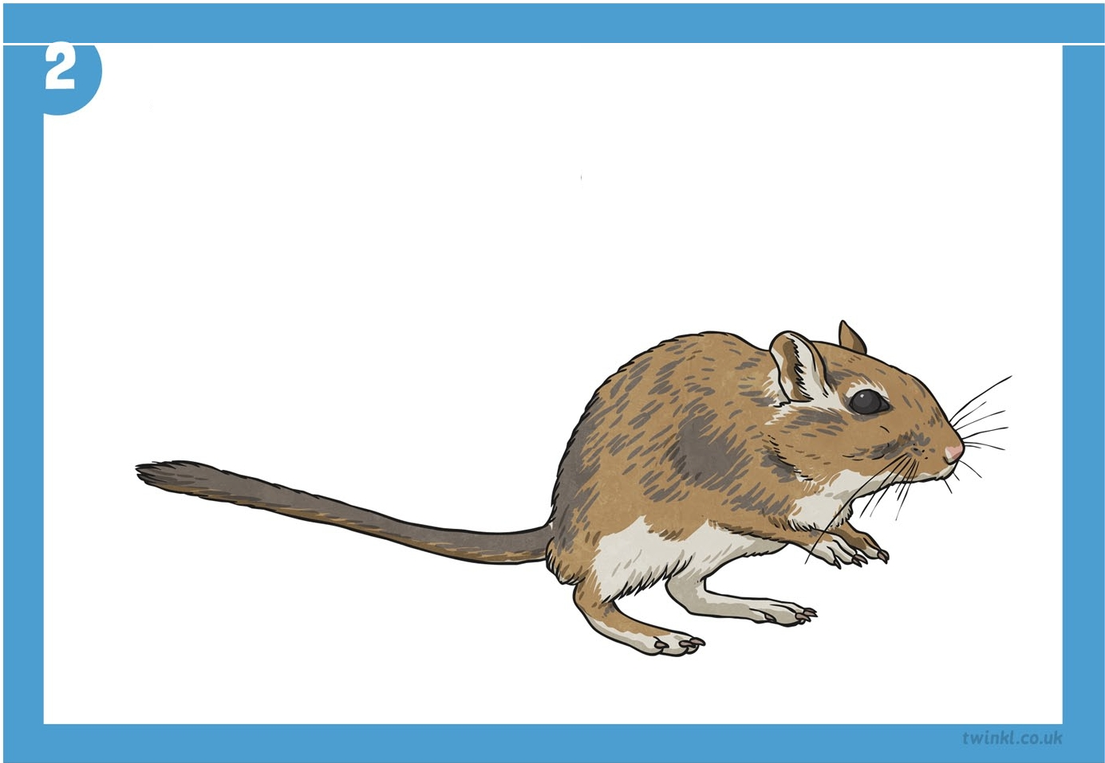

There are 56 legs.
How many spiders are there?

There are 44 legs.
How many gerbils are there?

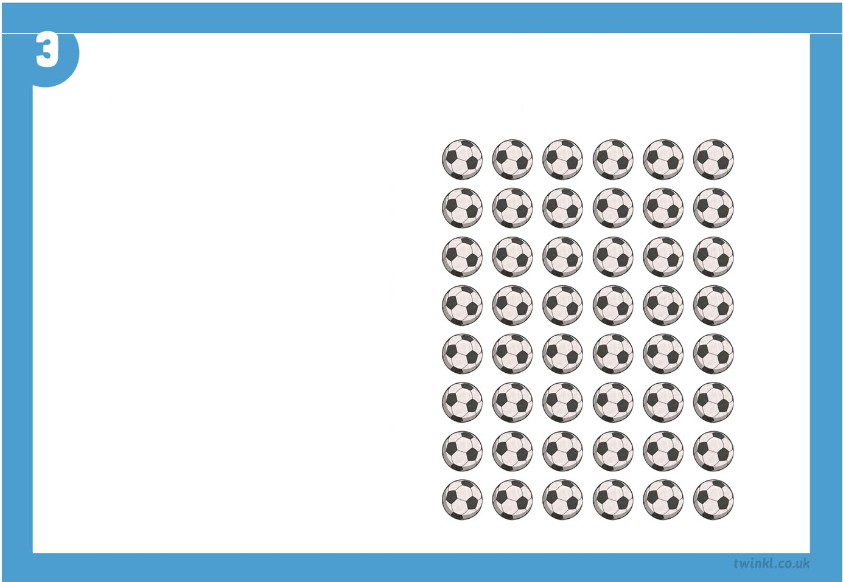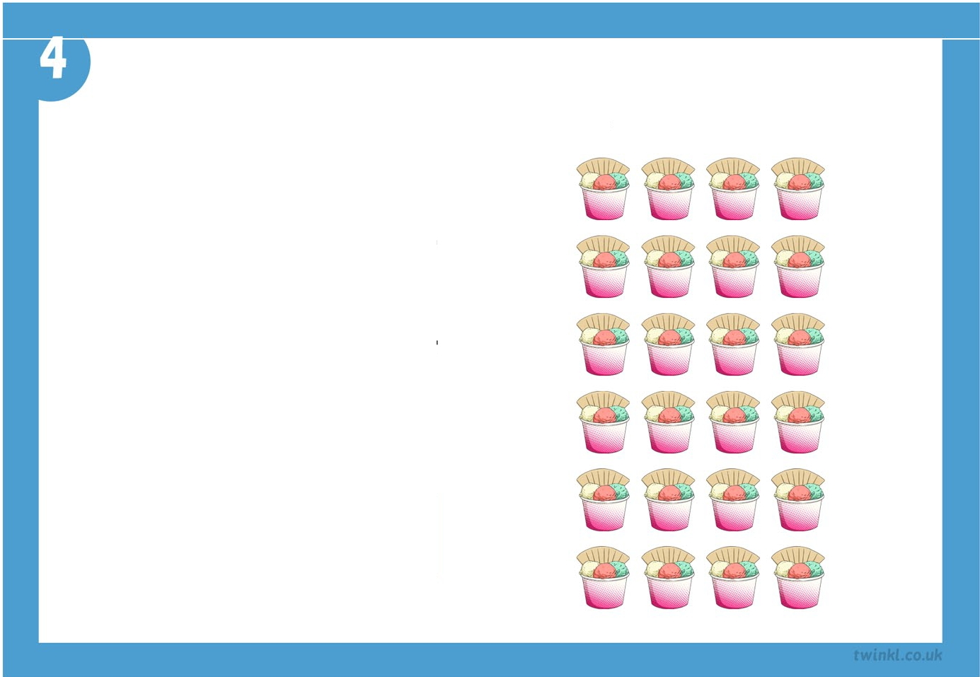
Complete the facts about this array.
6x D =48
8x D =48
□
48+8=□
+6=8
4x D= 24
Complete the facts about this array.
6x D =24
□
+6=4
24 + 4 =
□

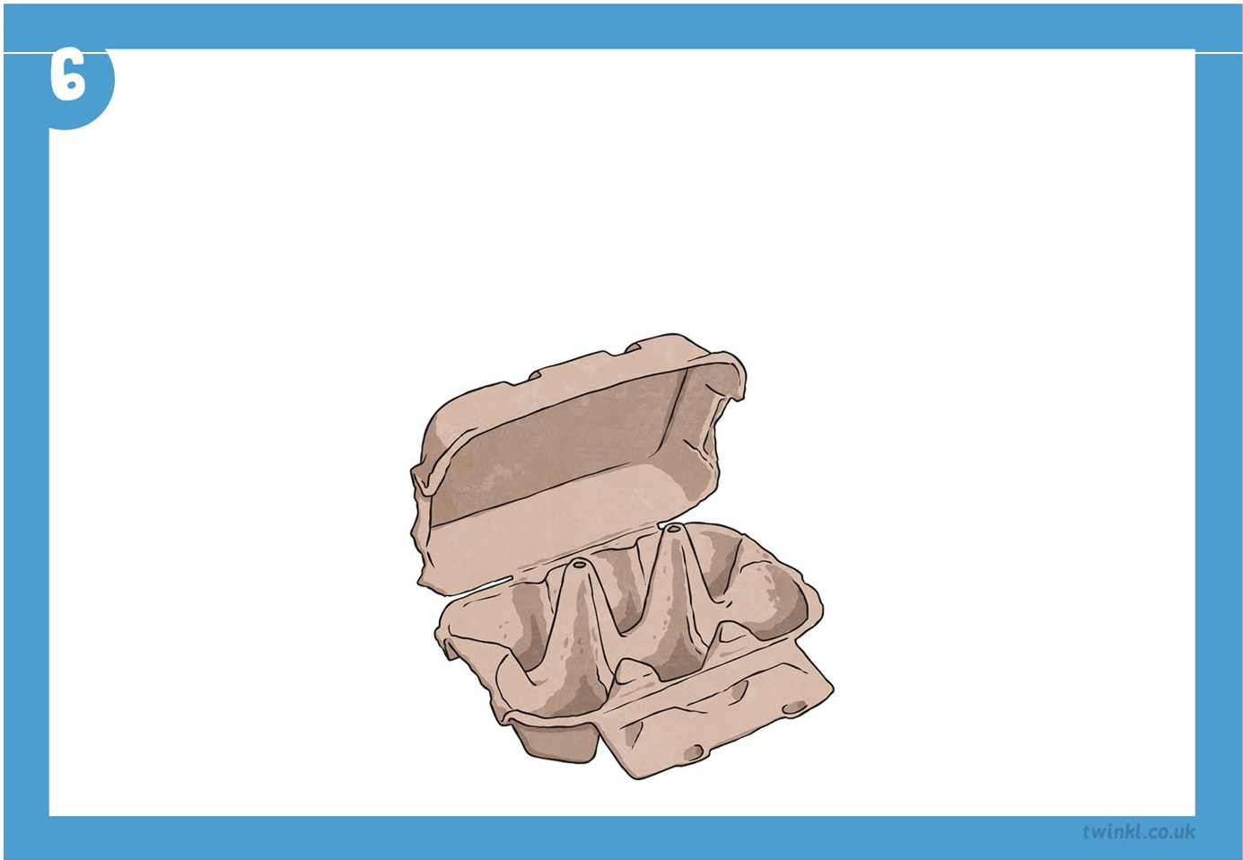
Wh.at does Q represent?
2 _{X} Q = 24
Q X 2 = 24
24 + Q = 2
24 + 2 = Q

How man egg boxes would ou need if Helen th.e h.en laid 50 eggs?

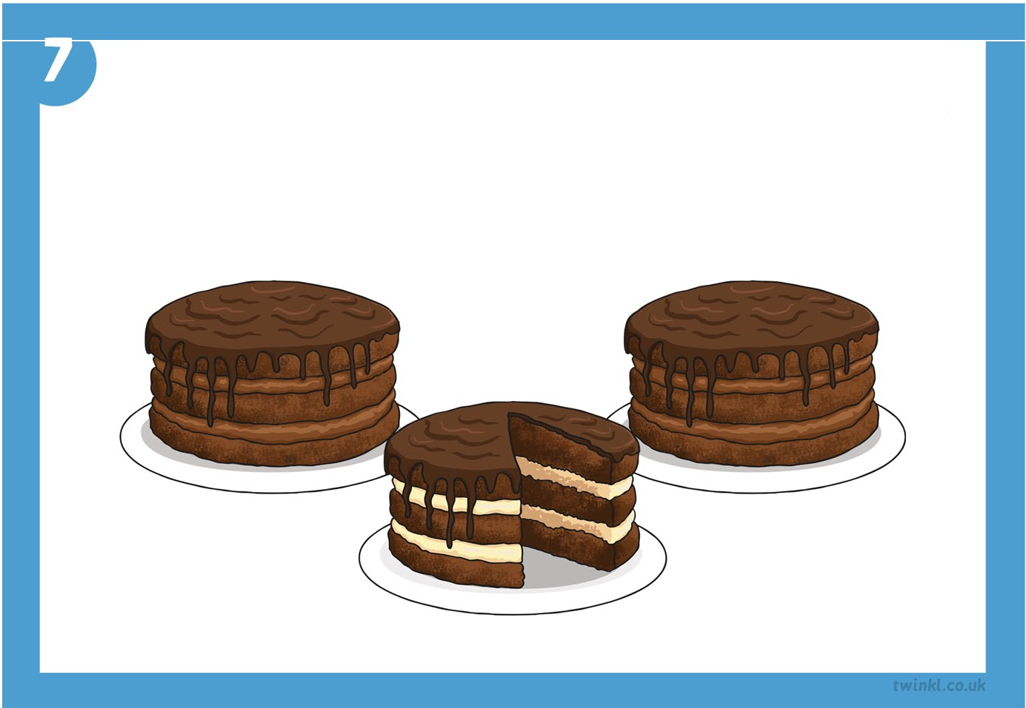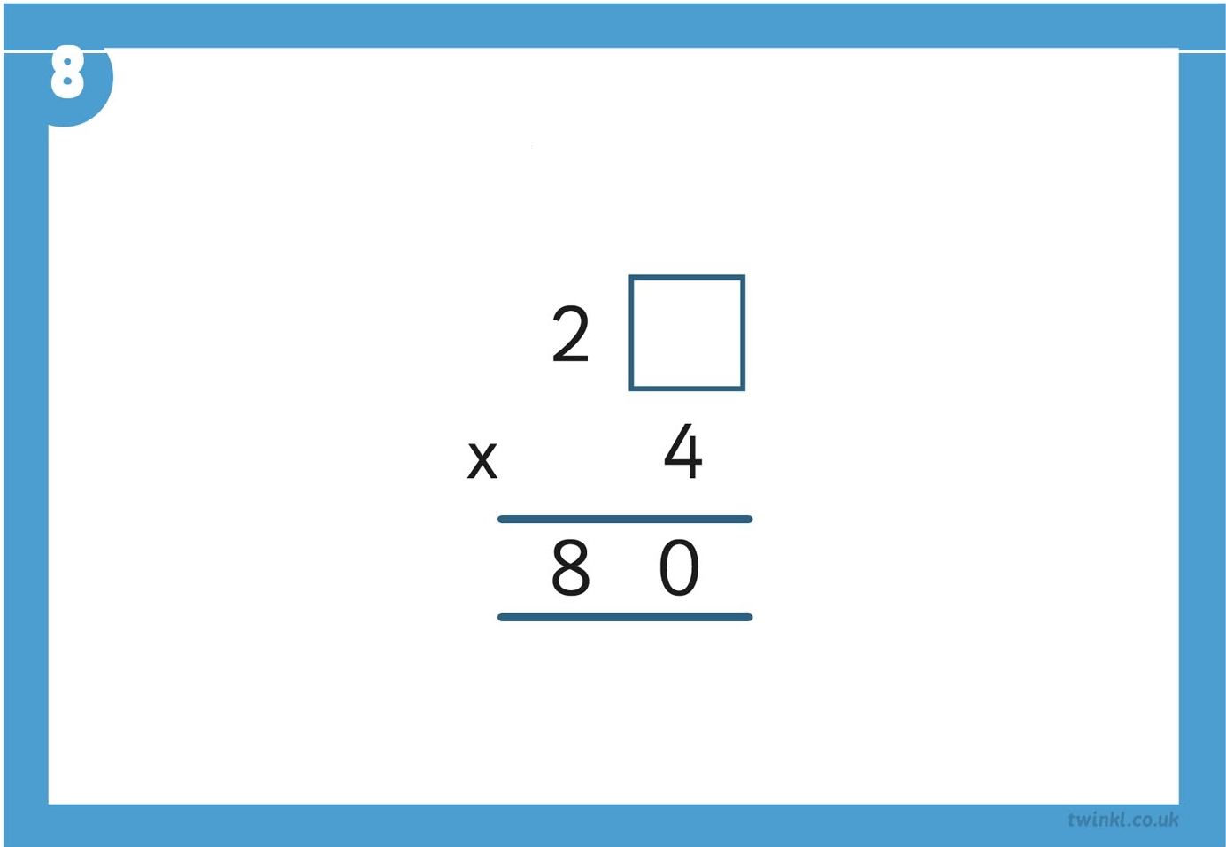

If I shared 3 cakes between 12 children h.ow much. cake would each. ch.ild get?
Find th.e missing digit.

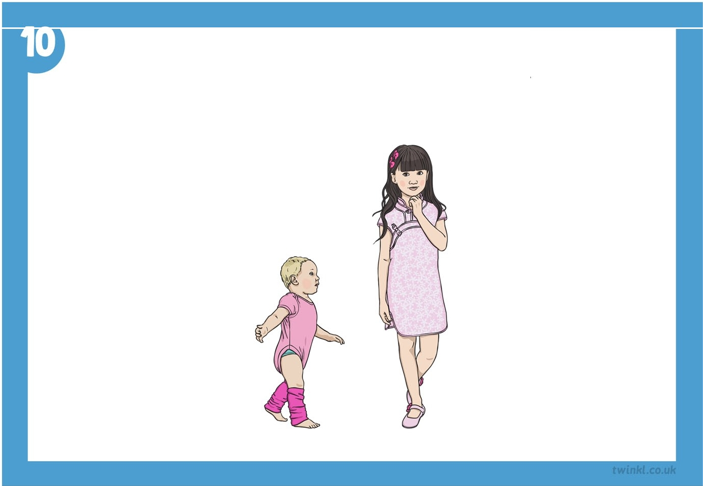

Wh.at are th.e missin.g n.umbers in. th.ese multiplication. grids?

Soph.ie is twice as tall as h.er bab sister Luc . If Soph.ie is 140cm tall h.ow tall is Luc ?
X | 30 | 4
7 | 300 | 40
8 | 7 | 32

X | 20 | 3
8 | 160

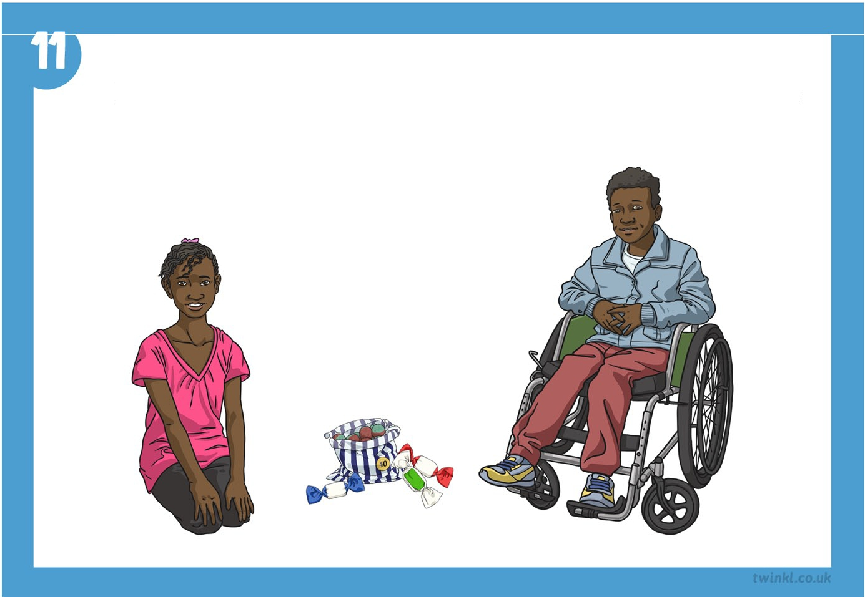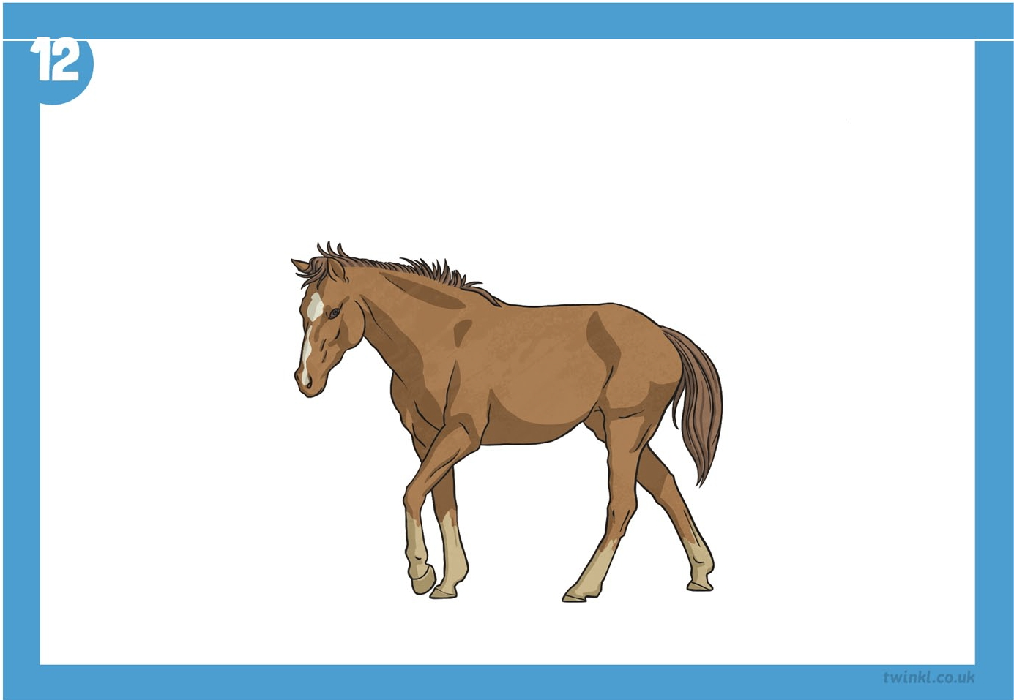

If Kabir h.as 4 sweets an.d h.is sister Amaira h.as 4 times as man. . How man. sweets does Amaira h.ave?

How man. are left over wh.en. 67 apples are sh.ared equall between. 8 h.orses?

Use a stopwatch to time yourse .
How quickly can you write out your 8 x table like this:

1x8=8
2x8=16
3x8=?
4x8=?

Up to 12 x 8.
Use a stopwatch to time yourse .
How quickly can you write out your 4 x table like this:

1x4=4
2x4=8
3x4=?
4x4=?

Up to 12 x 4.

Use a stopwatch to time yourse .
How quickly can you write out your 3 x table like this:

1x3=3
2x3=6
3x3=?
4x3=?

Up to 12 x 3 .
Find the incorrect number in these sequences.
a)
4,8, 12, 14,20, 24, 28,32.
b)
64,56,46,40,32,24, 16,8.
c)
6,9, 12, 16, 18,21,24.

1. There are 56 legs.  How many spiders are there?  Answer:  7 Spiders | 2. There are 44 legs.  How many gerbils are there?  Answer:  11 gerbils
3. Complete the facts about this array .  Answer:  6 X 8 = 48  8 X 6 = 48  48 6 = 8  48 8 = 6 | 4. Complete the facts about this array .  Answer:  6 X 4 = 24  4 X 6= 24  24 6 = 4  24 4 = 6
5. What does represent?  Answer:  = 12 | 6. How many egg boxes would you need if Helen the hen laid 50 eggs?  Answer:  9 boxes
7. If I shared 3 cakes between 12 children how much cake would each child get?  Answer:  A quarter of a cake | 8. Find the missing digit.  Answer:  0

plan it Maths I I Multiplication and Division I Challenge Cards Answers

9. What are the missing numbers in these multiplication grids?  Answer:  Ix I 20 1 3  Is I160 I 24  Ix I 30 1 4  I 10 I 300 I 40  Is I 240 I 32 | 10.Sophie is twice as tall as her baby sister Lucy. If Sophie is 140cm tall how tall is Lucy?  Answer:  70 cm
11.If Kabir has 4 sweets and his sister Amaira has 4 times as many. How many sweets does Amaira have?  Answer:  16 sweets | 12.How many are left over when 67 apples are shared equally between 8 horses?  Answer:  3 apples
13.How quickly can you write out your 3 x table like this?  Answer:  Times will vary . | 14.How quickly can you write out your 4 x table like this?  Answer:  Times will vary.
15.How quickly can you write out your 8 x table like this?  Answer:  Times will vary . | - .Find the incorrect number in these sequences.  Answer:  - 14 should be 16  - 46 should be 48  - 16 should be 15

plan it Maths I ear I M ultiplicationand Di i ion I Challenge Car d Ans ers

