Caesar’s Calendar Conundrum
Quick Questions

9
18
29
39
50
60
67
75
84
95
105
116
125
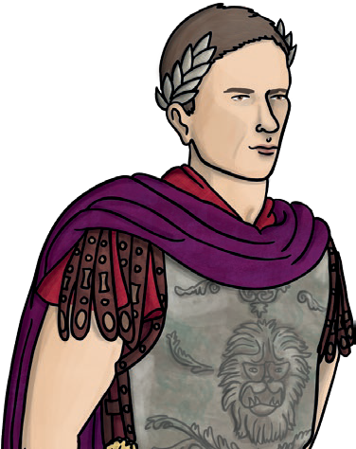
130
The Julian calendar, created by Julius Caesar in 46BC, was a correction of the Roman calendar - a complicated lunar calendar based on the phases of the moon. It needed a group of scholars to regularly meet and decide when days should be added or removed to keep the calendar in line with the seasons. In order to create a standardised calendar, Caesar worked with an astronomer named Sosigene, and together they made a solar calendar based entirely on the Earth’s journey around the sun. This calendar had a regular year of 365 days, split into twelve months, with a leap year added to February every fourth year. At the time, February was the last month of the year. However, the Julian calendar was replaced by the Gregorian calendar in 1582.
- Which calendar was based on the moon?

- Recap the main points of this text in 20 words or less.

- Why do you think that the Julian calendar was replaced?

- How does the Julian calendar compare to the calendar we use today? Explain your answer.

visit twinkl.com

visit twinkl.com

Caesar’s Calendar Conundrum
Answers

9
18
29
39
50
60
67
75
84
95
105
116
125
130
The Julian calendar, created by Julius Caesar in 46BC, was a correction of the Roman calendar - a complicated lunar calendar based on the phases of the moon. It needed a group of scholars to regularly meet and decide when days should be added or removed to keep the calendar in line with the seasons. In order to create a standardised calendar, Caesar worked with an astronomer named Sosigene, and together they made a solar calendar based entirely on the Earth’s journey around the sun. This calendar had a regular year of 365 days, split into twelve months, with a leap year added to February every fourth year. At the time, February was the last month of the year. However, the Julian calendar was replaced by the Gregorian calendar in 1582.
- Which calendar was based on the moon?

Accept: (the) Roman calendar.

- Recap the main points of this text in 20 words or less.

Accept any reasonable summary which includes that Caesar attempted to correct the existing calendar from lunar to solar and is 20 words or less.

- Why do you think that the Julian calendar was replaced?

Accept an answer which states that it possibly became incorrect, became outdated or was later found to be wrong.

- How does the Julian calendar compare to the calendar we use today? Explain your answer.

Accept any reasonable answer which states a relevant similarity or difference found within the text.
visit twinkl.com

visit twinkl.com

