2016 national curriculum tests
Key stage 2

English reading
Reading answer booklet

First name
Middle name
Last name
Date of birth | Day |  | Month |  | Year
School name
DfE number

E00050A0120

[BLANK PAGE]
Please do not write on this page.

Page 2 of 20
E00050A0220

Instructions

Questions and answers
You have one hour to complete this test, answering the questions in the answer booklet. Read one text and answer the questions about that text before moving on to read the next text. There are three texts and three sets of questions.
In this booklet, there are different types of question for you to answer in different ways. The space for your answer shows you what type of answer is needed.
Write your answer in the space provided. Do not write over any barcodes.

Short answers
Some questions are followed by a short line or box. This shows that you need only write a word or a few words in your answer.

Several line answers
Some questions are followed by a few lines. This gives you space to write more words or a sentence or two.

Longer answers
Some questions are followed by a large box. This shows that a longer, more detailed answer is needed to explain your opinion. You can write in full sentences if you want to.

Selected answers
For some questions you do not need to write anything at all and you should tick, draw lines to, or circle your answer. Read the instructions carefully so that you know how to answer the question.

Marks
The number under each line at the side of the page tells you the maximum number of marks for each question.
As this is a reading test, you must use the information in the texts to answer the questions. When a question includes a page reference, you should refer to the text on that page to help you with your answer.
You have one hour to read the texts in the reading booklet and answer the questions in this booklet.

E00050A0320

Page 3 of 20

Questions 1–11 are about The Lost Queen (pages 4–5)

Look at the paragraph beginning: Glancing nervously...
1

Find and copy one word meaning relatives from long ago.

1 mark

The struggle had been between two rival families…
2

Which word most closely matches the meaning of the word rival?

Tick one.
equal

neighbouring

important

competing

1 mark

Look at page 4.
3

How can you tell that Maria was very keen to get to the island?

1 mark

Page 4 of 20
E00050A0420

Look at the paragraph beginning: Oliver rowed...
4

Find and copy one word that suggests that the summer afternoon was quiet.

1 mark

...they crossed the glassy surface of the lake.
5

Give two impressions this gives you of the water.

1.

2.

2 marks

Look at the paragraph beginning: The tiny island... to the paragraph ending:
6
...were cut into it.

What impressions of the island do you get from these two paragraphs? Give two.

1.

2.

2 marks

Write down three things that you are told about the oak tree on the island.
7

1.

2.

3.

3 marks

E00050A0520

Page 5 of 20

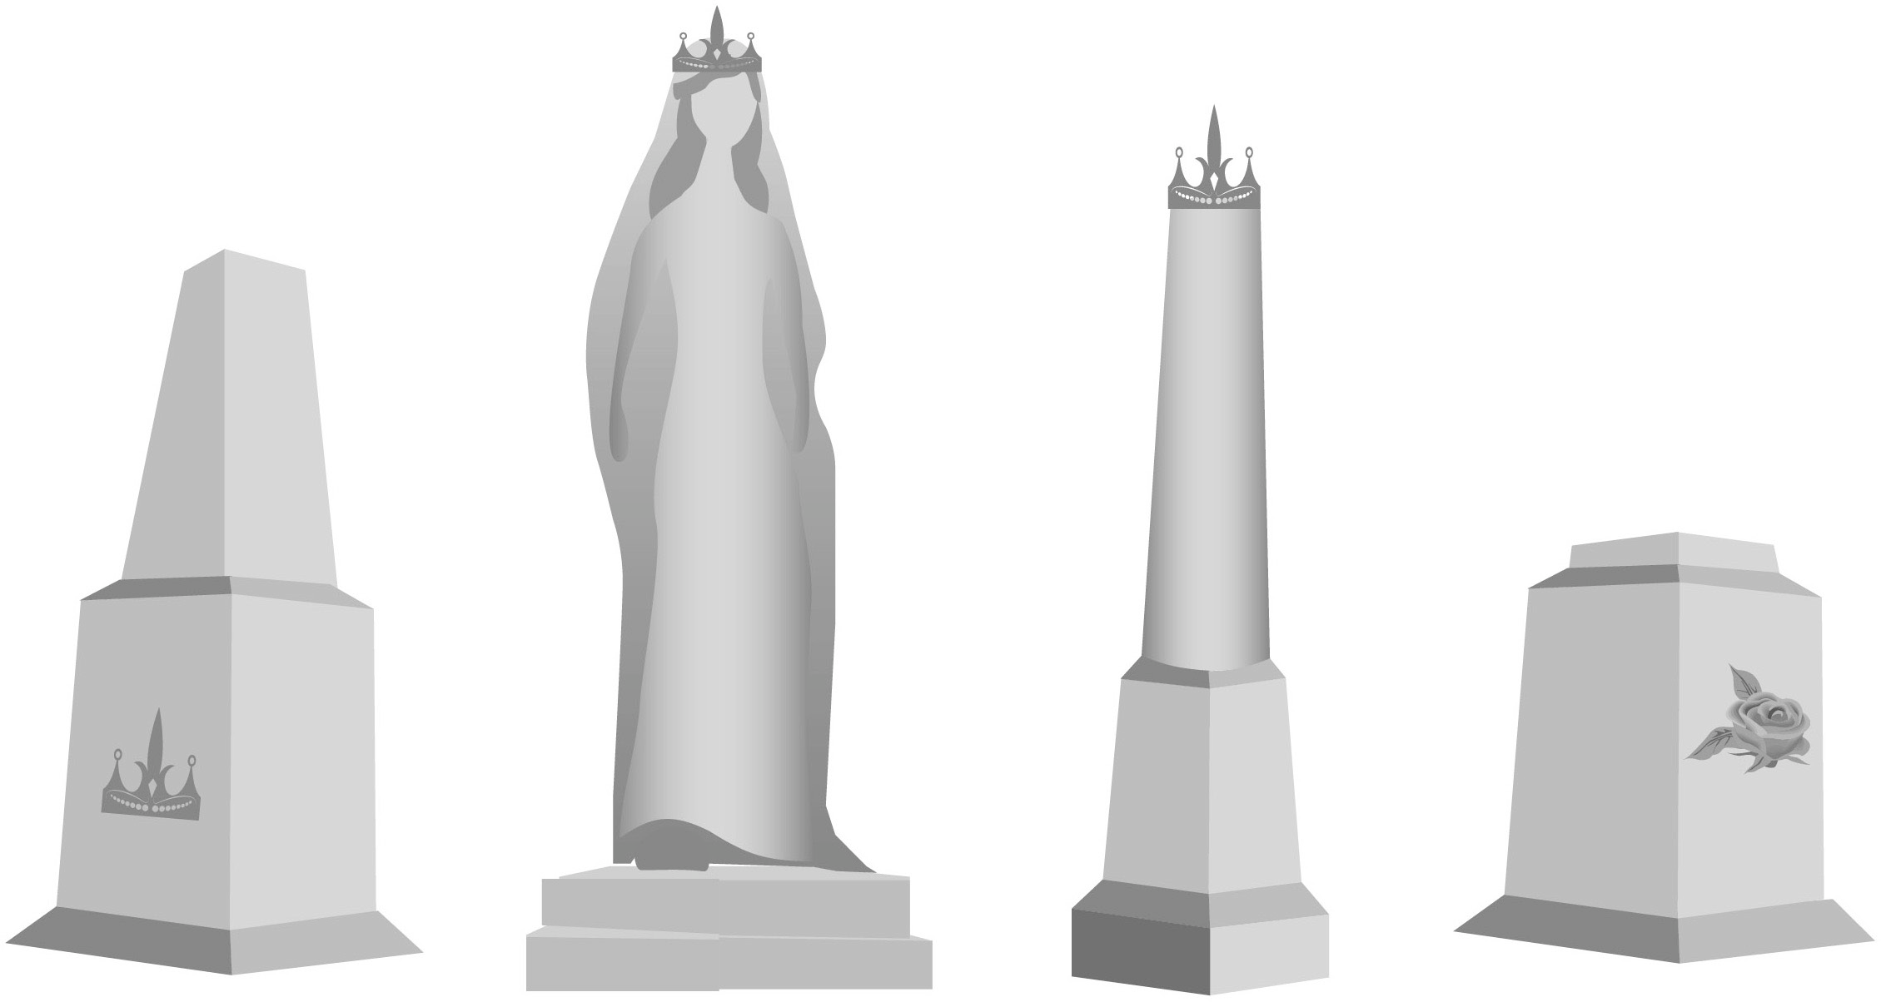Which of these drawings best represents the monument? Tick one.
8

1 mark

Look at the paragraph beginning: Maria led Oliver...
9

- Why did Oliver find it difficult to read the inscription on the monument?

1 mark

- What did he have to do in order to read the inscription?

1 mark

Page 6 of 20
E00050A0620

What was revealed at the end of the story?
10

Tick one.
Oliver was keeping a secret.

The monument was damaged.

The two families were still enemies.

Maria’s family did not win the throne.

1 mark

Using information from the text, tick one box in each row to show whether each statement is true or false.
11

 | True | False
Two families fought for the throne.
Maria’s family symbol was the lion.
The monument was for a prince.
It was hot on the island.

- mark

E00050A0720

Page 7 of 20

Questions 12–22 are about Wild Ride (pages 6–8)

Circle the correct option to complete each sentence below.

  - The text begins with Martine going out to ride her giraffe…
12
in the early morning.
at midday.

1 mark

  - Martine rode her giraffe…
in the late afternoon.
at night.
slowly.
speedily.

1 mark

  - Everything was fine on that day until…
safely.
fearfully.
her grandmother saw her.
they came across lions on the hunt.

1 mark

  - At the end of the text, Martine…
they disturbed a warthog family.
they met a herd of hippos.
ran home to get help.
cried all the way home.
went back home unharmed.
carried on riding for hours.

1 mark

Page 8 of 20

E00050A0820

Look at the first paragraph, beginning: Dawn was casting...
13

How do you know that Martine wanted to keep this ride a secret?

1 mark

What were Martine’s grandmother’s rules about riding the giraffe?
14

Tick two.

Ride only in daylight.

Don’t show off.

Stay in the game reserve.

Keep to a slow speed.

No jumping.

1 mark

E00050A0920

Page 9 of 20

- What evidence is there of Martine being stubborn in the way she behaved with her grandmother?
15

Give two points.

1.

2.

2 marks

- What evidence is there of Martine being determined when she met the warthogs?

  - mark

…milled around in bewilderment (page 8)
16

Explain what this description suggests about the baby warthogs.

  - marks

Page 10 of 20
E00050A01020

What evidence in the text is there that warthogs can be dangerous? Give two examples.
17

1.

2.

- marks

What helped Martine to get safely on Jemmy’s back after the warthog’s attack?
18

1 mark

The warthog mother made grunts of triumph (page 8). Why was she triumphant?
19

1 mark

E00050A01120

Page 11 of 20

Do you think that Martine will change her behaviour on future giraffe rides? Tick one.
20
yes

no

maybe

Explain your choice fully, using evidence from the text.

- marks

Page 12 of 20

E00050A01220

In what ways might Martine’s character appeal to many readers? Explain fully, referring to the text in your answer.
21

3 marks

Draw lines to match each part of the story with the correct quotation from the text.
22

setting
For a while Martine had defied her
past events
In the instant before her body parted company
action
Dawn was casting spun-gold threads

1 mark
That would teach her to show off
lesson

E00050A01320

Page 13 of 20

Questions 23–33 are about The Way of the Dodo (pages 10–11)

Look at the paragraph beginning: For thousands of years...
23

What does the word spat suggest about how the island of Mauritius was formed?

1 mark

Curious and unafraid, the animals of Mauritius offered themselves up for slaughter... (page 10)
24

Why were the dodos curious and unafraid?

1 mark

Find and copy one word from page 10 that tells you that some of the animals on Mauritius were only found there.
25

1 mark

Page 14 of 20
E00050A01420

- Give two reasons why Mauritius was a paradise for animals before humans arrived.
26

1.

2.

Look at the paragraph beginning: One of the victims… to the bottom of page 10.

- Give two reasons why the dodo became extinct after humans arrived.

1 mark

1.

2.

1 mark

Look at the paragraph beginning: One of the victims…
27

What does the word invaders suggest about the humans arriving on Mauritius?

1 mark

Why were artists’ drawings from the time of the dodo not always accurate?
28

1 mark

E00050A01520

Page 15 of 20

The mud flats would have formed a freshwater oasis in an otherwise
29
parched environment.

Give the meaning of the word parched in this sentence.

1 mark

Look at the paragraph beginning: Then, in 2005...
30

Find and copy one word or group of words that shows that scientists were not sure what happened to most of the animals during the drought on Mauritius.

1 mark

What does rehabilitate the image of the dodo mean?
31

Tick one.
restore a painting of the dodo

rebuild the reputation of the dodo

repair a model of the dodo

review accounts of the dodo

1 mark

Page 16 of 20

E00050A01620

According to the text, how did the discovery of the dodos’ bones help to change the image of the dodo?
32

1 mark

Below are some summaries of different paragraphs from this text. Number them 1 – 6 to show the order in which they appear in the text. The first one has been done for you.
33

An important lesson is learnt.

Reasons for the extinction of the dodo.

Summary of the plight of the dodos.
1

New information is discovered about the dodo.

An explanation for the unreliable evidence.

Humans arrived on Mauritius.

1 mark

E00050A01720

Page 17 of 20

[END OF TEST]
Please do not write on this page.

Page 18 of 20
E00050A01820

[BLANK PAGE]
Please do not write on this page.

E00050A01920

Page 19 of 20

2016 key stage 2 English reading Reading answer booklet
Print version product code: STA/16/7379/p ISBN: 978-1-78315-939-0 Electronic PDF version product code: STA/16/7379/e ISBN: 978-1-78315-940-6
For more copies
Additional printed copies of this booklet are not available. It can be downloaded from www.gov.uk/government/publications.
© Crown copyright and Crown information 2016
Re-use of Crown copyright and Crown information in test materials
Subject to the exceptions listed below, the test materials on this website are Crown copyright or Crown information and you may re-use them (not including logos) free of charge in any format or medium in accordance with the terms of the Open Government Licence v3.0 which can be found on the National Archives website and accessed via the following link: www.nationalarchives.gov.uk/doc/open-government-licence.
When you use this information under the Open Government Licence v3.0, you should include the following attribution: ‘Contains public sector information licensed under the Open Government Licence v3.0’ and where possible provide a link to the licence.

Exceptions – third-party copyright content in test materials
You must obtain permission from the relevant copyright owners, as listed in the ‘2016 key stage 2 tests copyright report’, for re-use of any third-party copyright content which we have identified in the test materials, as listed below. Alternatively you should remove the unlicensed third-party copyright content and/or replace it with appropriately licensed material.

Third-party content
These materials contain no third-party copyright content.

If you have any queries regarding these test materials contact the national curriculum assessments helpline on 0300 303 3013 or email assessments@education.gov.uk.

E00050A02020

