Bruno stood at the entrance to his Father’s office, waiting for permission to enter. Once he had been summoned, he entered to see his Father sat perched against his desk; he didn’t even turn to acknowledge Bruno. He turned to face his son, “Gretel informs me that you keep asking about the people you have seen around this place Bruno.” Bruno considered his response, wondering how honest he should be. “Yes Father,” Bruno stared at the floor, avoiding eye contact with his Father, “I have seen them from the window.” “You must stay away from them Bruno! They are filthy beasts and you have nothing in common with them. Do you understand me?” Father’s face told Bruno how serious he was. “Do not think of them and do not go near that place, that's all I ask.”
Bruno knew how serious his Father had been; his demands could not have been clearer. However, there was nothing left for him to explore inside the house; he also questioned what his father had said- they’re filthy? That can’t be right. He had spoken to Pavel in the past, he had helped look after him, and he knew he was a good man. As Bruno entered the garden, Pavel was on his knees in a flowerbed, gardening. Pavel heard Bruno approaching and turned towards him, lowering his gaze. “Pavel, I need your help. I need to get out of the house an you’re going to help me.” Pavel and Bruno both knew what they were about to do was wrong; Bruno’s father would not have approved- however, they found themselves walking closer and closer, step-by-step towards the exit of the garden.
Pavel followed behind his young companion; partly because it was clear that it was Bruno leading this exploration and partly because he was struggling to keep up with the boy. Pavel was weak and frail and it was an almighty effort to keep on going. They eventually neared a clearing in the woods and Bruno found what he had been searching for- the farm. However, on closer inspection, it looked nothing like what he had imagined. Little wooden fences were replaced with huge wire ones topped with barbed wire; in the distance, workers were replaced with people that looked like Pavel. Closer to them was a boy sat on the floor cross-legged. Bruno tilted his head and looked confused, “What is this place Pavel?” His companion refused to answer. The boy on the floor found the courage to speak, “A prison,” he muttered, “it’s to keep us hidden away from the world.” “Is that true Pavel? Are these people prisoners?” Bruno could not believe what he was hearing. “We have to do something!”
***
“Bruno?...Bruno!...BRUNO! Where are you?” The first time his mother spoke she inquisitive, by the time she had searched the house and there was no reply to her calls, she was frantic. She had noticed a number of things out of place: food was missing from the pantry, Bruno’s school bag was not on its usual hook and Pavel had not been seen for hours. Immediately, she called Lieutenant Kotler into the house and instructed him to search the grounds for her missing son.
***

Bruno’s mind was spinning, he could not understand what he had just been told. “Father would never…” His voice trailed away as he thought back to the meetings he had seen his father have with the other soldiers in their impressive uniforms. In his heart, he knew this to be true. “We have to do something Pavel! We can’t leave him there.” Bruno pushed the fence, looking for weaknesses. “Pavel! Help!” Sinking to his knees, the elderly man began to paw at the dirt, looking to dig underneath the fence; on the other side of the Shmuel did the same. The earth had been softened by the recent rain and it didn’t take long until they had dug to the bottom of the iron fence and created a hole wide enough for a small boy to fit through. Shmuel emerged from the crater a little muddy, a little grazed but relieved to be on the outside of the fence. Bruno’s face lit up, he knew he had done the right thing. “We need to go Master Bruno! If they see us, they will kill us!” The three unlikely companions made their way into the nearby woods, hoping to remain undetected.
Kotler was flanked by a patrol of six soldiers that had separated themselves across the forest, sweeping their way through, scouring for Bruno. They stalked the woods, eagle-eyed, looking for signs that Bruno had passed this way. The first sound to split the silence was the sound of Kotler’s German Shepherd barking constantly, the second sound was the terrified screams of two young boys that stood protected by an elderly gentleman. The remaining soldiers arrived moments later, rifles raised. Kotler raised his hand instantly, commanding the soldiers to hold their fire. “Bruno…come and stand by me!” Kotler instructed, his voice was icy and unwelcoming, “Bruno, do as you are told and I will report only good things to your father.” Hesitantly, reluctantly, Bruno made his way from behind Pavel towards the soldiers. As Kotler led Bruno away he nodded to the soldier nearest to him. Bruno wriggled to turn and see but Kotler was too strong for him, the only thing he could make out was the sight of the soldiers closing on his friends.
GDS to attempt to write snippets of overheard speech to infer the 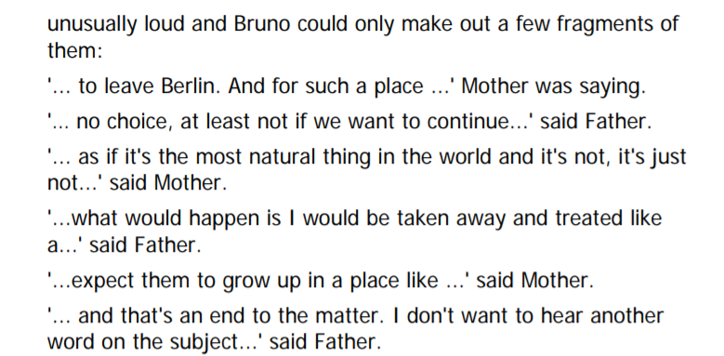

Several days later, a black car pulled up at the front of Bruno’s house, the car was adorned with two fire-red flags with white circles in the centre and four hooked crosses within. A man emerged from the passenger seat, he was not very tall, but dressed in a heavy grey overcoat with a military cap under his arm, a small moustache sitting above his upper lip; as he passed the guarding soldiers they stood up straight, snapped their feet together and clicked their heels once, quickly and loudly. Their right arms shot out in the air, just above their shoulders and they all exclaimed in unison, “Heil, Hitler!”
From within the office, the man’s fury could be heard. Bruno’s father remained silent throughout. The only time he spoke was when the man entered and left to salute and say the phrase.

