KS2 Problem of the Day
Tuesday 20th March 2018

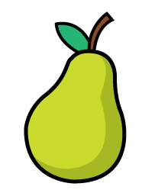 1 Here are two identical rectangles.
For every 5 lemons there are 3 pears.
3 A bag contains some lemons and pears.

3 m 8 cm
What is the length of one of the rectangles?

2 What fraction of the shape is not shaded?

There are 18 more lemons than pears. How many lemons are there in total?

