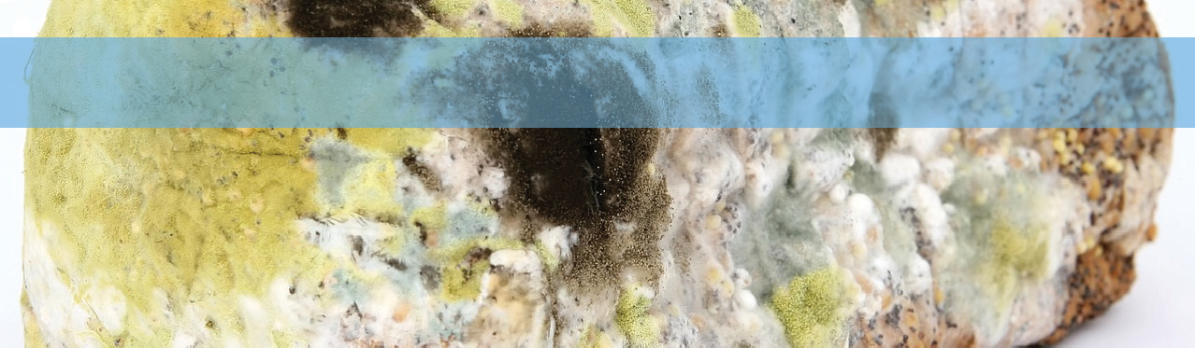
Unit focus: British Innovators
Text focus: Biography (980L)
STAGE 6

Alexander Fleming
In early 1941, a policeman named Albert Alexander scratched his face on a rose bush. The cut soon
became infected and he eventually lost an eye and was close to death. Luckily for Alexander, a new miracle medicine was ready to be tested: penicillin. The effect of the drug was almost immediate and he soon recovered. Unfortunately, scientists at the time were unable to produce enough of the drug to keep his infection at bay, and he passed away four days later.
Nevertheless, scientists had seen how effective this medicine could be, a medicine that owed its discovery to a British scientist named Alexander Fleming. Fleming was born in Scotland in 1881 but moved to London when he was 13. He trained as a doctor and began a career in research at the University of London. It was there that he began to take a detailed interest in illnesses and vaccines.
When the First World War broke out, Fleming served in the Army Medical Corps with distinction. Once the war was over, he returned to his research. It was at this time that he made his most famous discovery, one that would very nearly save the life of Albert Alexander and actually save the lives of millions of people worldwide.
In 1928, Flemming decided to take a holiday. Before he left, he set up a series of petri dishes with cultures of staphylococci; a bacteria that causes a lot of serious infections. Luckily for science, he appears to have a left a window open while he was away. This meant that spores of a particular type of mould (Penicillium) were able to drift into the lab and land on the dishes. When he returned, Fleming discovered that the bacteria in his dishes hadn’t grown where the spores had landed.
Immediately, Fleming knew that this particular type of mould had stopped the infectious bacteria from spreading. He made a note of the discovery, but he was a very busy scientist. He put the discovery to the back of his mind and carried on with his other research.

It wasn’t until an Australian scientist named Howard Florey began looking for a medicine that would do exactly what Penicillium had, that Fleming’s work was rediscovered. It was under Florey’s watchful eye that Albert Alexander was treated.
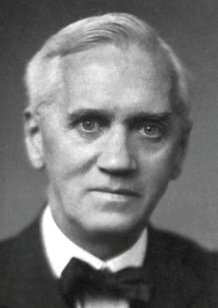
The problem with penicillin was that it was very hard to produce enough to make it a useful medicine. Scientists just could find the mould or get it to
reproduce. During the Second World War, a lady named Mary Hunt discovered the mould growing on a melon in a grocery store. Scientists finally had a large enough sample to reproduce. In fact, every bit of penicillin made to this day is descended from that single melon!
In 1944, Alexander Fleming was knighted for his services to science, and in 1945 he was awarded the Noble Prize for Medicine. He shared the award with Florey and a man named Ernst Chain, who had worked closely with Florey. He died
on the 11th March 1955 but his memory lives on with the
wondrous penicillin.
INFERENCE FOCUS
- How do you think scientists felt when they saw the effect of penicillin on Albert Alexander?

- How do you think they felt when he passed away?

- Why does the author say it was “luckily for science” that Fleming left a window open?

- Why didn’t Fleming try to investigate the mould as soon as he noticed it?

- What can you tell about Florey from the phrase “Under Florey’s watchful eye”?
S
R
V
E
Who died after scratching their face on a rose bush?

Find the sentence that begins “In fact, every…”. Why does it end with an exclamation mark? Which word has a definition closest to “Even though this had happened”?
Where was Alexander Flemming born?

List the series of events that led to Fleming discovering penicillin.
R
VIPERS QUESTIONS

Answers:

- Excited, positive etc

- Determined to work out how to produce more, now they’d seen how it worked

- If he hadn’t the spores might not have landed on the dish

- He was busy with other jobs and didn’t have time

- He was a careful doctor who kept a close eye on what was happening

R: Albert Alexander

E: It is surprising that all penicillin is related to one sample

V: Nevertheless

R: Scotland

S: He set up the petri dishes, he went on holiday, spores landed on the dishes, he noticed that the bacteria hadn’t grown

